CURRICULUM VITAE

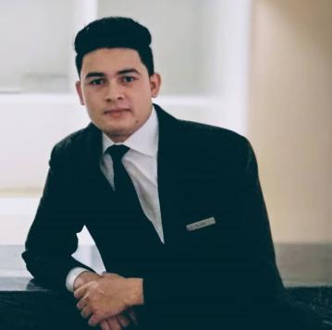  SURYA PRATAP SINGH  Phone: +91 9711650865  Skype: live:.cid.3450ab7f8a09eac1  Email: suryasingh2997@gmail.com  Linked: https://www.linkedin.com/in/surya-pratap-718271176  PERSONAL INFO  Date of Birth : 29th May ` 1997  Gender : Male  Nationality. : Indian Marital Status. : Unmarried Language. : English and Hindi Passport no.: U6888014  Hobbies & Interest  Listening to music, collecting photographs  SYNOPSIS OF ACHIEVEMENTS:  Appreciation letter from ITC GRAND CHOLA CHENNAI  Represented Hyatt Regency New Delhi in Auto Expo 2018. | SUMMARY:  Energetic with 5+ year experience in restaurant operation management within the hospitality industry .  To be placed in a reputed concern where my skill and talent will be use to achieve the organizations goals and which in turn will enhance my capabilities  CORE COMPETENCIES:  - Visionary Leadership  - Operations Management  - Training and development  - Menu Planning  - Guests Equity  - Inventory Control  CAREER GRAPH:.  - Hyatt Regency New Delhi,  Since 2017 to till now  - Position- Restaurant Supervisor ( The China Kitchen & Bar)  - The flagship hotel of Hyatt hotels in India near Chankayapuri, located in Delhi’s central business district. Comprises of 508 rooms including 51 suites. Hosting 7 of the city’s most acclaimed restaurants and bars, renowned for delectable cuisine from India, Italy, Middle East, Chinese and Oriental.  - Best Chinese Restaurant and Bar by Easy Diner 2016, Best restaurant runner up in India by Condensate Travelers and Readers Choice Awards2016, 2018 and 2019  - Experience of Coffee shop (Cafe ) as a supervisor  Duration- One Year  - Experience of Banquet as a Guest service associate .  Duration- Seven Months  - Experience of Fine Dine Italian restaurant (La Piazza) Guest Service associate  - Duration- Two month  - Experience of In room dinning as a Guest service associate.  - Started my carrier from In Room Dinning in The Grand New Delhi  Duration- One year (June 2016-may 2017)  - Successfully completed 6 months of Industrial Training And 6 month of On Job Training from ITC GRAND CHOLA , CHENNAI  ACADMIC QUALIFICATION:  Successfully completed Bachelor of hotel management from Uttrakhand open university  10+2 from UK Board  DUTIES AND RESPONSIBILITIES:  - Planning and executing day to day operations in coordination with Kitchen, Food and Beverage Cost Control, Materials and Purchase, Sales and Public Relations.  - Performs opening and closing procedures established for the department.  - Check in with guests to ensure satisfaction with each food course and or beverages.  - Serves guests their food and beverage in prompt, courteous manner as per the standard sequence of service  Date : Signature :  Place  Surya Pratap Singh

