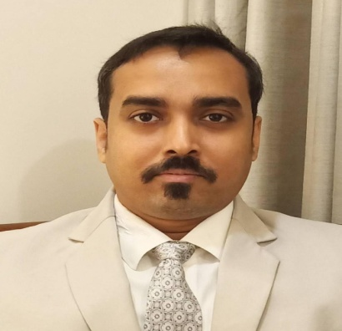

Career Objective:
To seek a challenging position in Food & Beverage Services of such an organization where I will be able to contribute to the organization’s growth and profitability with my skills and in turn get an opportunity to gain exposure and expertise that would help me to build strong and successful career.
SOVAN NANDY
Mobile No: 08073788522 
Passport Number:
T4329300
Email:
Sovannandy0@gmail.com
Skype id:Sovannandy0@gmail.com

Profile:
3 years Diploma in Hotel Catering Technology with Specialization in Food & Beverage Service from Dolphin School of Hotel Management, Kalyani (approved to Annamalai University, UGC Recognized, Ministry of HRD, Govt. of India and Certified by ISO 9001-2000) under WBUT.


Work Experience:
The pride Ahmedabad,I The Pride, Ahmadabad, India

November 2011 to June2012

Position: Waiter

Job Profile:
Effectively managed of a130 covers coffee shop & room service.
Run the operation smoothly maintaining hotel’s brand standards.
Handled guest complaints
Handled cash.



One Continent Atria, Hyderabad, India
July, 2012 to August 2015
Position: Sr. waiter
Job profile;
Effectively managed of a 90 covers coffee shop &110 rooms room service.
Run the operation smoothly maintaining Brand Standards
Maintain all f & b registered.
.


Royal Orchid Bangalore, India

October2015 to October 2016

Position: Tr. Captain
Job profile:
Effectively managed of a 132covers coffee shop, &195 rooms room
Service.
Run the operation smoothly maintaining hotel’s brand Standard.
Handled guest complaints.
Handled cash.
Maintain staff duty register, Staff allocation.
Maintain departmental register


The Park Hotel Bangalore, India

November 2016 to May 2019

Position: Captain
Job profile:
Effectively managed of a room service& 60 covers Coffee shop & 109
Room service.
Run the operation smoothly maintaining hotel’s brand standards.
Handled guest complains
Handled cash.
Maintain staff duty register, Staff allocation.
Maintain departmental register
Handel event of the day.


Raviz Center Point Hotel Dubai, UAE.

July 2019 to May 2020.

Position: F&B supervisor , Banquet Sale Coordinator

Job Profile:
Effectively managed of a102 covers coffee shop,& 109 rooms , room
Service.
1000sqft banquet booking & banquet operation.
Run the operation smoothly maintaining hotel’s brand standers.
Handle guest complains.
Cash handle.
Maintain staff duty roaster, staff duty allocation.
Maintain departmental register.
Attend F&B meeting with HOD & General Manager.

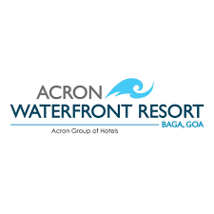

Acron WaterFront Resort Goa , India

October 2021 to till date .

Position: Senior F&B Executive.

Job Profile:
Effectively managed of a72 covers coffee shop,& 102 rooms , room
Service.
Two banquets hall, one open pool side sea view area. Two Jacuzzi & Two
Swimming pools.
Run the operation smoothly maintaining hotel’s brand standers.
Handle guest complains.
Cash handle.
Maintain staff duty roaster, staff duty allocation.
Maintain departmental register.
Attend F&B meeting with HOD & Resort Manager.

Other Exposure: (casual Training)

Training from Hyatt Regency Kolkata, Peerless INN Kolkata,
Hindustan International Kolkata, The Kenilworth Kolkata,


Industrial Exposure
Successfully completed 5 months industrial training from
Hotel Le Meridian Ahmadabad.
Successfully completed 12 months’ job training from Hotel
Le Meridian Ahmadabad.

Personal Details:
Father’s name: Late Ashim Kumar Nandy
Date of Birth: 4th January, 1988
Nationality: Indian
Marital status: Married
Gender: Male
Height: 5ft 5 inches
Weight: 70 kg
Passport Number: T4329300
Languages known: English, Hindi & Bengali
Academic Qualification:
Madhyamik(10th)West Bengal Board of Secondary
Education 2005
Higher Secondary (10+2) West Bengal Council of Higher
secondary 2008.

Professional Qualification:
Done (3) years Diploma in Hotel Management &Catering from
Dolphin School of Hotel Management, in 2010.

Co-Curricular Activities:
Dinning out, socializing, Personal fitness

Strengths:
Active team builder to achieve goals for/by the team
Good communication skills, reliable steady and diligent worker
Open-minded and ability to think on my feet.

Date:- Signature
Place:-
Sovan Nandy

