CURRICULUM VITAE
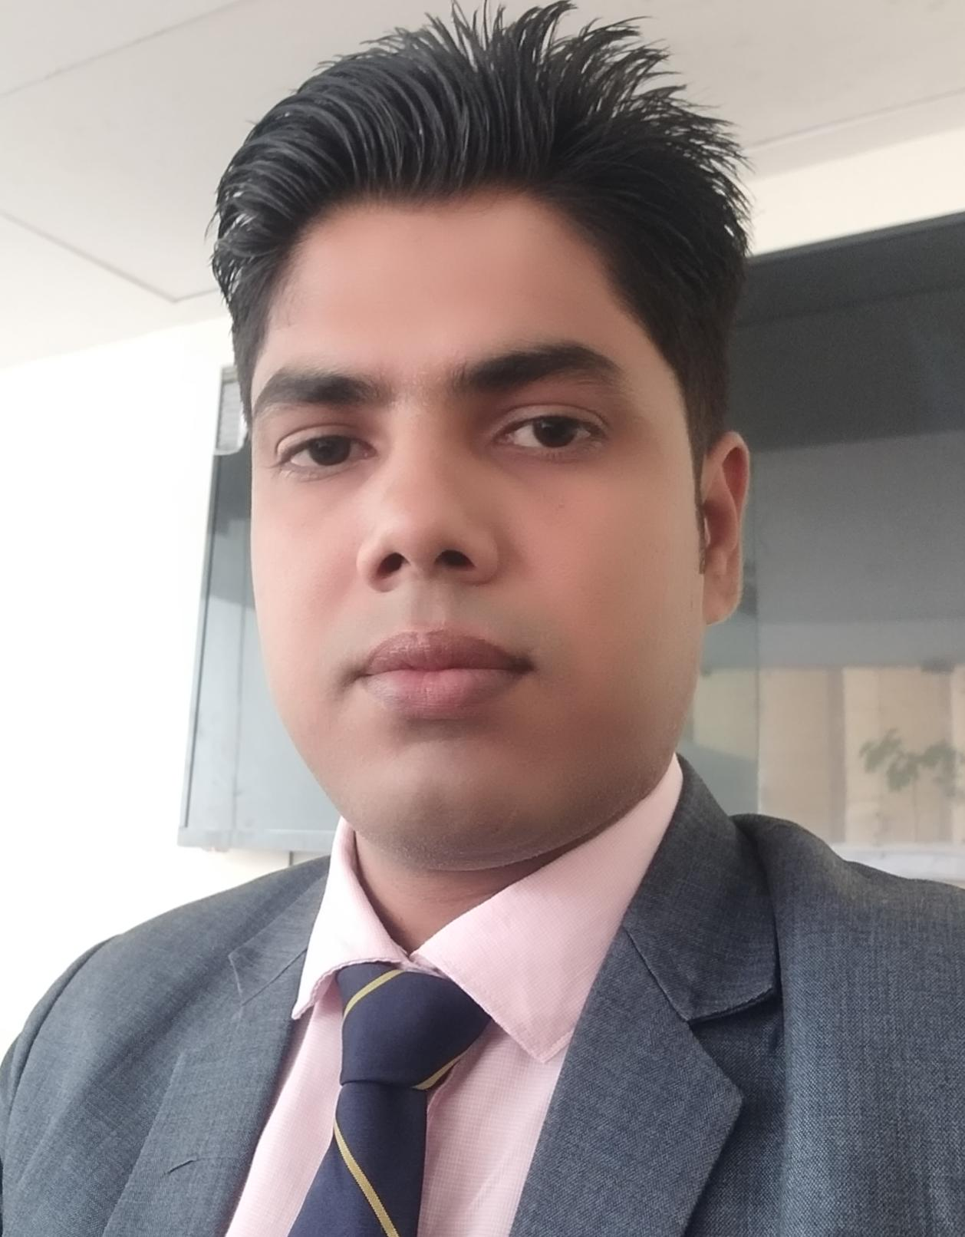

SK. Nuruddin
C/O- sk waresh Ali
Arjun Dihi , katwa, burdwan, west Bengal
Mobile: 7984482391
Email: sknuruddin26@gmail.com

Carrer Objective
I wish to be an asset to the organization and positively contribute towards taking the company on the next level with my diligence, integrity and expertise.
Summary & Strength:
- A competent professional with over 8 years of working experience in Hospitality Industry with sound knowledge of Food & Beverage.
- Excellent Guest Relation skill.
- Positive, upbeat approach to employee relations and guest complaints.
- Software knowledge for IDS Fortune

Current Profile:-
*Currently working as assistance manager banquet sales in Hotel Babylon capital Raipur, till date.
* Worked as a Banquet sales executive at Hotel Binori in Ahmedabad from 23rd 2019 to 30th march 2020.
*Worked as F&B & banquet sales executive at Hotel Grand O7 Ahmadabad from10th December 2015 to 15th December 2018 , and looking after Banquet Operation & Sales and till now able to generate successful business through Corporate & Travel Domain, MICE.
- Generated business from leisure as well as corporate Mice
- Group programs.
- Brief to staff for technical sound less service & increase the revenue end of day.
- Reservations and Booking for food and beverage as well as banquet also.
- Conducting staff training program, as well as sales analysis (budget, & achievement), Diaries Guest feedback, Maintaining hygienic and Cleanness.
- Managed day to day operations of the banquet facility. This included booking and confirming a broad range of events up to 240 people in multiple rooms for both corporate and social events.
- Negotiated pricing including sales minimums and menu pricing, conduct site visits, prepare and send out proposals and contracts and assist with menu selection with great attention to detail.
- Up sold menu items to maximize revenues while providing increased value and an exceptional experience to our guests.
- Effectively communicated and work closely with Banquet, Culinary and all other operational departments to ensure smooth execution of all events including conducting weekly Banquet Event meetings with the Executive Chef and pre shift meetings with the Captains and Servers.
- Prospected new business by conducting quality outside calls and networking including attending marketing events.
- Continually met and exceed revenue goals.
- New client acquisition and maintaining good sales record.
- Maintained information on competition’s performance, sales & marketing strategy etc.
Professional Experiences:-
*Worked as Senior Captain from 21st February 2014 to 9th December 2015 in Regenta by Royal Orchid at Ahmedabad.
- Preparing breakage report & briefing sheet.
- Reconciliation of billings and KOT system.
- Overall looking the Restaurant operation and supervising the junior staff.
- Making M.I.S. reports, Reservation, Guest Feed Back System & Mystery Audit
Overseeing the day by day operation & Inspect food & beverage service in restaurant

*Worked as a Captain from 8th January 2013 to 20th February 20 14 in St.Laurn Tower at Ahmedabad.
- Generate BQT function prospectus and release under concern departments.
- Establish staffing schedules, assigned responsibilities for steward.
- Preparing briefing sheet and brief to staff in each session.
- Shift handling and supervising food & beverage service flow.
- Submitting Inventory and preparing store indent and also daily sales Report
- Dairies guest comments card & maintain daily wise all Log books.

*Worked as a S.R GSA from 08th February 2011 to 07th January 20 13 with Shree Balaji & Group at Ahmedabad.
- Operated Banquet function & handling banquet.
- Organize all assets in proper place at store day by day.
- Make a report of crockery, cutlery Inventory Of Banquet equipments.
- Preparing ODC check list.

*Worked as a GSA from 25th February 10 to 7th January 11 in Hotel East Place at Kolkata.
- Preparing Mise-en-place for the operations.
- Sequence wise servicing the customer's menu orders.
- Set up restaurant as well as back areas.

Training Profile.
- Industrial training has completed in The GOLDEN PARK, WEST BENGAL for six months from 17TH August to 18th Feb 2010.

Software Proficiency:-

Operating Systems: Windows98/XP/2000/2007.

Packages: MS Office- Word, Internet

Hotel software IDS Fortune.
Awards & Achievement:
- Awarded as a best service in Hotel East Place at Kolkata.
- Awarded as a best service in Hotel St.Laurn Tower at Ahmedabad.
- Awarded as a best service in Hotel Grand O7

Professional Qualification:-

- Completed One and Half year Diploma in FOOD BEVARAGE Catering Technology and Management from MACK SCHOOL OF HOTEL MANAGEMENT, Kolkata, West Bengal in 2009.
- Completed the certificate course for Food & Beverage in Service Dept. from IHM Kolkata in 2011.
Academic Qualification:-
- Passed 10+2 from West Bengal Board, KATWA 2009.Passed 10thform West Bengal Board, ALAM PUR in the year 2007.

PERSONAL DETAILS
Name : SK Nuruddin
Father's Name : SK Waresh Ali
Date of Birth : 26 September 1991
Permanent Address : ArjunDihi , katwa, burdwan, west Bengal
Marital Status : Unmarried
Hobbies : Playing Football ,Listen Music
Nationality : Indian
Language : Hindi, English & Bengali & Gujarati.
Will furnish on request
I hereby declare that the above furnished details are as per undersigned believed and best of the knowledge based on true certificate.
Place :
Date ……………
SK Nuruddin

