SEKH RUHUL AMIN
Mail:-aruhul761@gmail.com Call:-08460969417, Vill+post:-kulbatpur.
P.S:- Purshura Dist:- Hooghly (W.B)712414
CURRICULUM VITAE

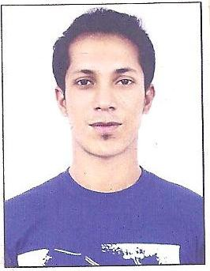
CAREER OBJECT

To work hard with grate loyality, sincerity and give my best to extract the qualities in herent

ACADEMIC CREDENTIAL

1) 10th Deulpara B.N.Vidyaniketan | -: | WBSC (2002)
2) 12th Deulpara B.N.Vidyaniketan, | -: | WBBHSE (2004)
3) Diploma in Hotel Management- | -: | T.S.H.M.COLLEGE.
WORKING EXPERIANCE

1) TGB CATERING | -: | 4 years as an assistant Manager
2) DEEWANE –E-KHASH | -: | 5 years as a Manager
3) JAY –MAA-CATERAR | -: | 2 year as a Manager
4) FOOD LINK BANQUET
CATERER SERVICE -: 1 years as an F&B Executive
5) MATUKI CATERERS -: Present working as a manager

PERSONAL PURTICULAR

Father name: - SK safiullah Mother name: - Mt rahima begum Date of birth: - 20 Nov 1986

PERMANENT ADDRESS

Vill + post :-kulbatpur P.S :-Purshura Dist : - Hooghly (W.B) 712414,
PRESENT ADDRESS

AMRITKUNJ APARTMENT ROOM NO-106
Housing, ashapuri 2
Pandesara, surat

Computer Skill : Basic knowledge of computer. Special Interest : Playing cricket and cooking. Language Known : English, Hindi, Bengali and Gujarati.

During my job period I have served the famous Punjabi food, pizza and pasta (atT.G.B surat) to Mr
Narendra Modi & Miss Amrita Arora and in that time I have meet and served.

Regards. Date: Ruhul Amin. Place:

