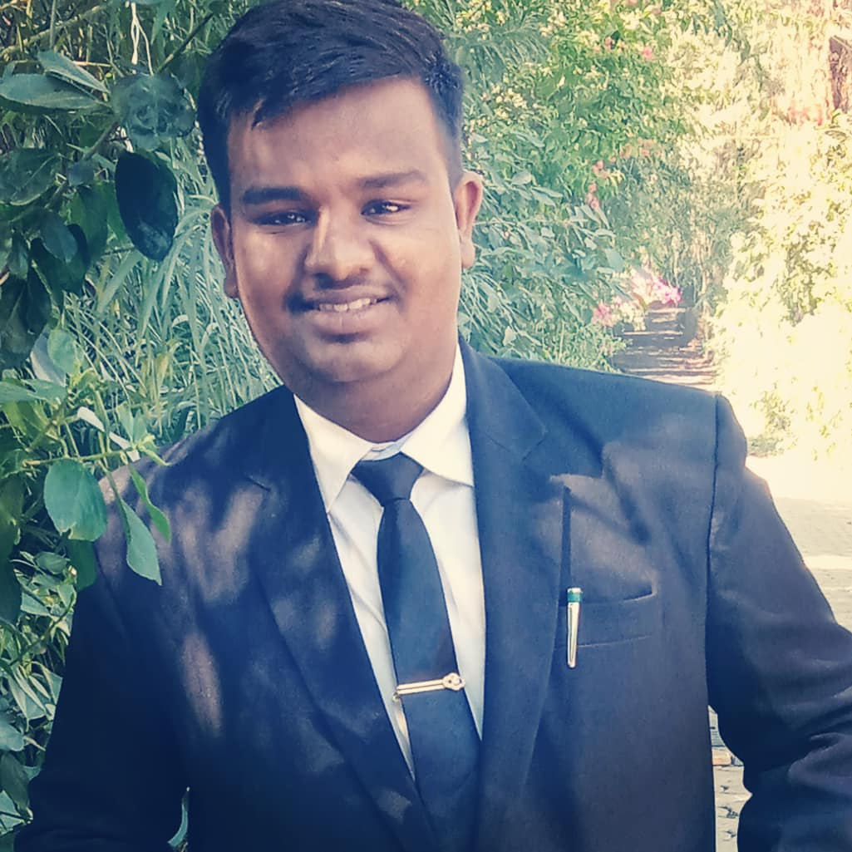 |  | * Objective :- To Maintain My All Dedications And Responsibilities Towards Hotel Industry , At My Working Place And To Utiliz My All Skills And Dedications Which Is Earn Through Ihm Bhopal .  * Education Qualifications :-  * Class 10th From CBSE  * Class 12th From MPBSE  * Short Diploma In Foregine Language French  * Diploma In Hotel Management From Institute Of Hotel Management , Bhopal  * Certificate Course In Communicative English From Bhopal The School Of Social Science .  * Right Now Pursuing Bachelor Of Arts In English Literature Government College , Nagda .  *Technical Skills :-  * Management Holder .  * Time Management .  * Decision Making .  * Guest Interaction .  * Good Communication .  *Experience :-  * Right Now I Have Completed My Industrial Training From Sayaji Hotel Ltd , Bhopal As In Below Departments Front Office , Housekeeping ,AND Food And Beverage Service .  * 3½ Months As Per My It Schedule .  Personal Profile :-  Name :- Yash Kerwar  Father's Name :- Mr Hemant Kerwar  Date Of Birth :- 06-09-2000. Age :- 21 Yrs  Nationality :- Indian  Marital Status :- Unmarried  Language :- Hindi , English , French  Aim :-  In Next 20 Years , I Want To See Myself As A Best Hotelier Across All Over The Country , Regarding Hotel Industry , My Dream Is To Elaborate My Skills To Upcoming Generation Who Are Going To Step words To Hotel Industry And To Elaborate Various Indian Hotel Tricks .

YASH KERWAR
RESUME

CONTACT
PHONE:
8269691684

EMAIL:
kerwaryash@gmail.com

