RATUL MUKHERJEE
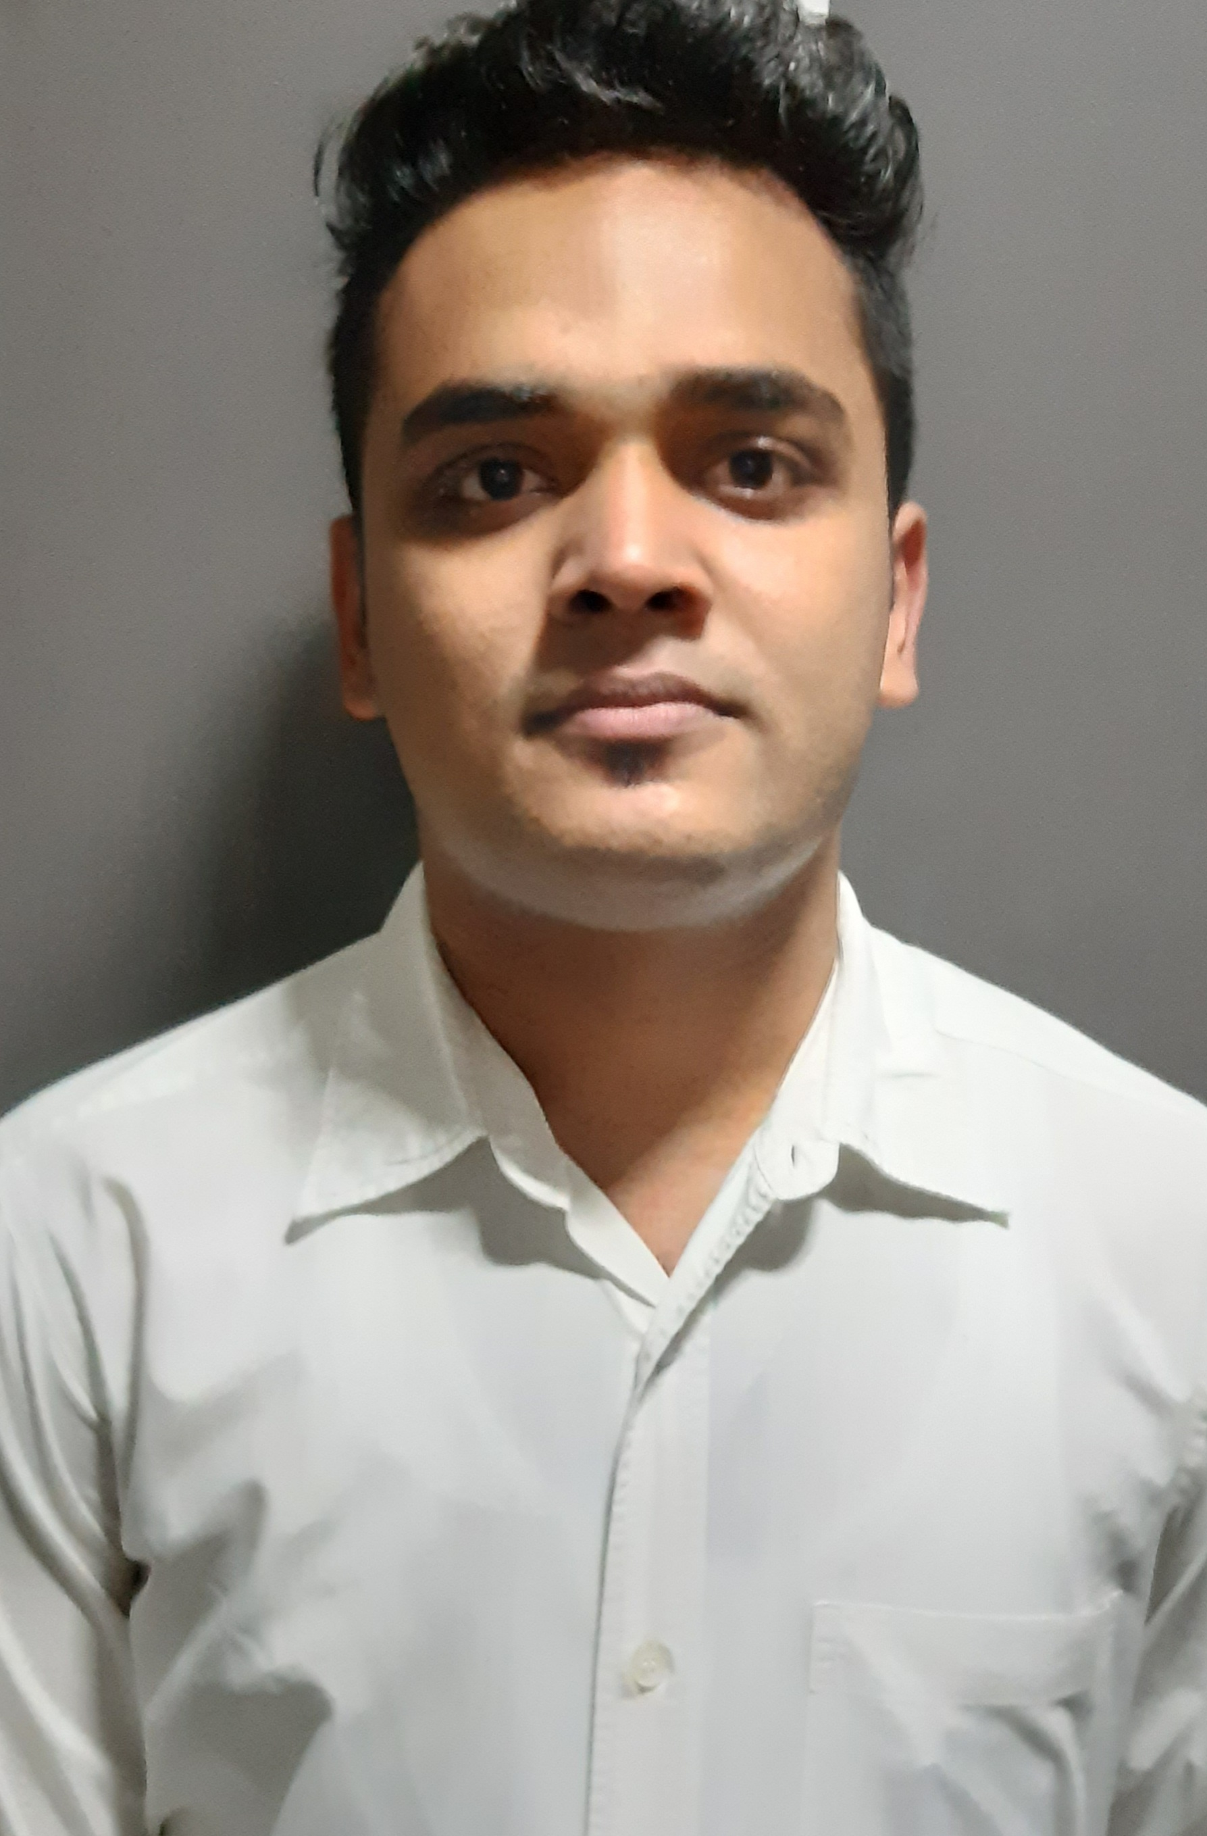

Phone: +918637090746/+917585063951

Email: ratulmukherjee08@gmail.com

CAREER OBJECTIVE

Achieving my own career goals by obtaining a challenging position in service industry, where opportunities for learning and scope of rapid growth and development exist, want to be creative while contributing towards the success of the company. I wish to be a valuable team player in a dynamic environment that provides me with a wide spectrum of exposure and sufficient challenges to enable me to constantly stretch the limits of my potential.

PROFESSIONAL QUALIFICATION

- I have obtained a Diploma on Hospitality Management, Travel Management and Customer Service from Frankfinn Institute of Airhostess Training Centre.

- I have got a diploma in Automated Financial Accounts from C.M.C Academy.

EDUCATIONAL QUALIFICATION

Name of the Examination | Board/  University | Year of Passing | Percentage
- Graduation | - N.S.O.U | - PURSUING | -
➢ Higher  Secondary | ➢ W.B.C.H.S.E | ➢ 2017 | ➢ 1st Division
➢ Secondary | ➢ W.B.B.S.E. | ➢ 2015 | ➢ 1st Division

WORK EXPERIENCE

Company Name - Marriott Suites Pune.
Designation - Guest service Associate in F&B(service) department.
Duration - Join by 26th AUG 2019 to 20th APRIL 2021.
Job Responsibilities –
- Making preparations for the room service and events.
- Maintaining the optimum stock level and following the flow of information.
- Holding several events such as birthday parties and conferences.
- Making the buffet arrangements and monitoring the tables laying.
- Handling the calls for the room service and negotiating with the guests about hotel facilities of service department.
- Managing the guest complaints.
- Handling Marriott Audit's
- Cashiering.

Company Name - Sheraton Hotel Hyderabad.
Designation - Guest service Associate in F&B(service) department.
Duration - Join by 5th sep.2018 to 12th of May 2019
Job Responsibilities –
- In charge of preparation, serving and cleaning.
- Do all preparation and special ready for the day.
- Make sure all food is served properly.
- Be professional at all time to guest may have contact with while on-duty.
Perform other duties that assigned by immediate or controlling supervisor.

ACTIVITIES AND ACHIEVEMENT

- I had done an UDAAN project (a team work with different People).
- 1st Star performer of the month of December, 2019.
- Best host for the month of November 2109.
- Social Media champion for the month of February 2020.

INTEREST AND HOBBIES

- Playing football.
- Visit New Places.
- Listening Music
- Gardening
- Drama

PERSONAL DETAILS

Father’s Name - Mr Asit Mukherjee
Permanent Address - Village -Sankarhati,
Post - Munshirhat, P.S - J.b.Pur,
Distic- Howrah
Pin - 711410
Date of Birth - 12th July, 1999
Gender - Male
Marital Status - Single
Language Known - English, Hindi and Bengali
Nationality - Indian
Religion - Hindu

STRENGTH

I am a hard working person, I do my job very well, and I am Confident about it. I’m serious about my job. I am very volatile with peoples.

PHYSICAL FACTOR

Height - 170 Cm.
Weight - 68 kg
Eye sight - 6/6

Date _____________ ____________________
Ratul Mukherjee
Place ____________

