CURRICULUM VITAE
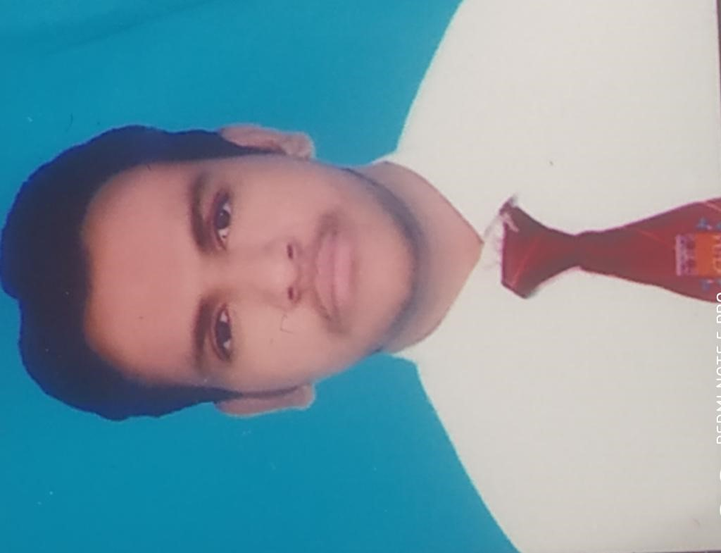
RAKESH CHANDRA PANERU
H. No. 254, NASIRPUR
Ghaziabad/ UP
Mob. : 9773739714/ 7678512499
E-mail : R.c.paneru 111@gmail.COM

CAREER OBJECTIVE
● To pursue a career in an organization that provides a challenging work environment and gives me a scope to update my knowledge and creativity in accordance with the latest trends in industry and by being part of a team that dynamically works towards growth of the organization.

JOB PROFILE
- Implementing the standard operation procedure as set by F&B
Manager Responsible for increasing overall productivity of outlets.
- Responsible to see that proper order is being taken during the operation. Assigned the duties to staff, take briefing, upward & downward communication.
- Responsible for proper care of equipment & inventory maintained of all operational equipment.
- Responsible for coordination with outlet head and all other supportive department of the Hotel.
- Handle the guest complaints. Find out solutions and make sure that the guest will be happy and satisfied.

PROFESSIONALQUALIFICATION
- Three year B.sc degree course of hotel management from CHM college Ghaziabad by Bharathiar University.
- PURSUING TWO YEAR MBA COURSE OF HOTELMANAGEMENT FROM CHM COLLEGE GHAZIABAD BY BHARATHIAR UNIVERSITY.

ACADEMICQUALIFICATION
● Intermediate from C.B.S.E. Board in 2015.
● High School from C.B.S.E. Board in 2013.

CERTIFICATIONS
- 4 months diploma in DFA(Basic computer and tally).
- F&B manager appreciate of training time doing the hard work
- Apperiaciate certificate give me General manager ( zone hotel)
- Star of the month certificate.

WORKINGEXPERIENCE
- 6 months industrial training complete from Evershine keys prima resort mahabaleshwar(Pune).
- 1 year and 2 months working experience as a Steward GSA in keyshotel.
- I have working experience as a Steward GSA in Ginger hotel(Gurgaon).
- I have working as a senior associate / GSA for zone by the park hotel
(Bangalore).
- I have also 1 Year working experience for Captain in F&B in Ginger Hotel IRR Bangalore .
- Recently i am working in Ginger Hotel RYN Delhi as a F&B Executive.
HOBBIES
- Playing cricket listening music.
- Hard workand
PERSONAL DETAILS
Father's Name | : | Sh. Prakash Chandra Paneru
Date of Birth | : | 05-06-1997
Gender | : | Male
Marital Status | : | Unmarried
Nationality | : | Indian
Languages Known | : | Hindi & English
DECLARATION
□ I hereby declare that all the above given information is true to the best of my knowledge and belief.

Date : (RAKESH CHANDRA PANERU)
Place : Ghaziabad /UP

