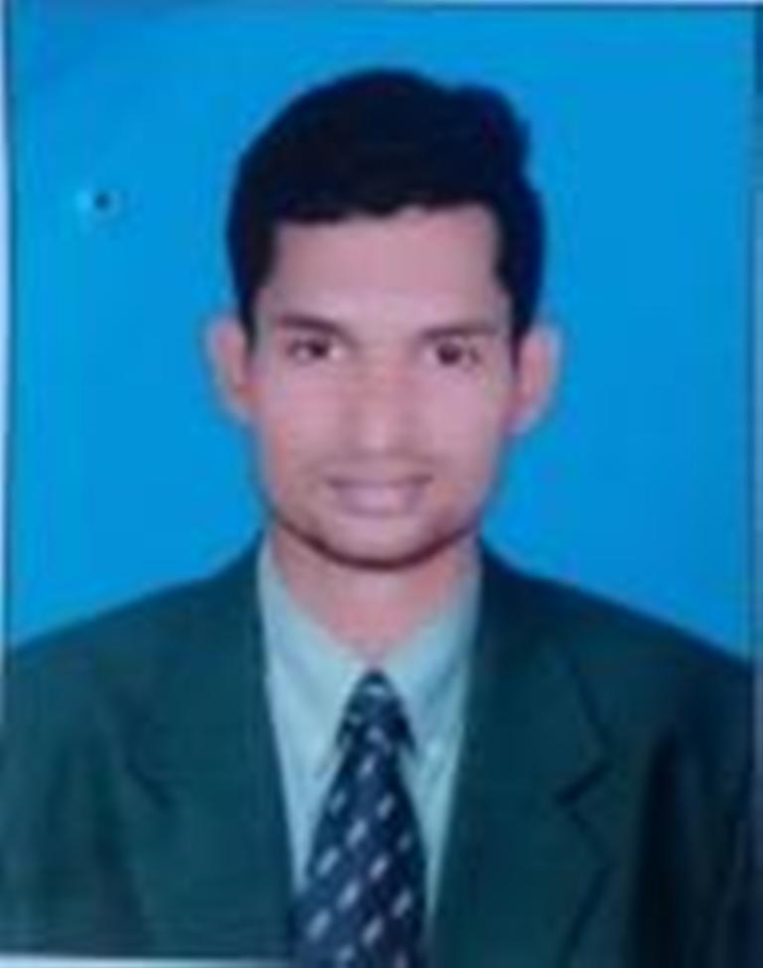  Raj kumar mandal  B.H.M.C.T  E-MAIL ID: gkuraj@gmail.com  MOBILE:  (+91)8872983995  WHATS APP  (+91)8872983995  ( INDIA)  Pan card/ license No:  DPTPM9554J  PASSPORT NO:  S3544951 | CURRICULAM VITAE  STATEMENT OF PURPOSE:  To seek a challenging and stimulating role in the organization where I can positively contribute my skills and utilize my creativity to meet the organization goal and acquire new skills in the process.  EXPERIENCE :  - Resort : - THE GOLD BEACH RESORT.  From – Apr 2019 to till date.  As:- FnB Executive  - Hotel: - SAROVAR PORTICO  From – Aug 2018 to Dec2018  As:- Trainee Captain .  - Resort : - THE GOLD BEACH RESORT .  From- Jan 2018 to Aug 2018.  AS:- Sr Steward  - Restaurant : - ZOUK RESTO BAR  From- Mar 2017 to Jan 2018  AS:- Steward.  - Hotel:- REGENTA ALMEIDA  From – Jan 2016 to Feb 2017.  As:- Guest Service Associate.  Job Responsibility:  - Research new wholesale food suppliers and negotiate prices.  - Manage and store vendors contracts and invoices.  - Maintaining Inventory of bar.  - Preparing reports at the end of the shift/operations.  - Planning and coordinating menu.  - Organizing promotional events and discount schemes.  - Snagging of restaurant.  - Maintain guest details  - Store requisition.  - Process payroll for all restaurant staff.  EXPERIENCE (Project):  - Hotel: RAMADA PLAZA (CHANDIGARH)  From – Aug 2015 to Jan 2016  As- Trainee  Learning:  - How to take care of Bar and Bar items  - How to serve to guest.
PERSONAL DETAILS:  FATHER’S NAME :  RAMNATH MANDAL  (Service Man)  MOTHER’S NAME :  BHULKUN DEVI  (Home Maker)  DATE OF BIRTH :  15th of MARCH 1996  SEX :  MALE  BLOOD GROUP :  A positive(A+)  NATIONALITY : INDIAN  MARITAL STATUS:  MARRIED  LANGUAGES KNOWN :  ENGLISH  HINDI  PUNJABI&GUJRATI (Understanding)  INTERESTS & HOBBIES:  Travelling,  Running,  Playing cricket.  CURRENT LOCATION:  INDIA | SEMINARS:  - HACCP  - FIRE  ACADEMIC RECORDS:  Bsc.H.M - Completed hotel management , from GURU KASHI UNIVERSITY  (Graduation) Academy accredited to AICTE and Degree Course  12th - Passed from BSEB PATNA, S.G.S.M.S.M.N.N.J College, KHAJEDIH in the Year 2014 with 61 %.  10th - Passed from +2HIGH School,KHUTAUNA,  Under BSEB PATNA in the year 2012 with 60 %.  ACHIVEMENTS:  - Awarded as the best employee of the year in The REGENTA ALMEIDA.  - Awarded as the best employee in The gold beach resort for a month.  - Participated in YOGA competition in school and got 10th position in Bihar .  - Winner in 4*100 miter race.  COMPETENCIES:  Good Communicator, Very patient, Optimistic, Hard working, Able to adjust with any sort of environment, Disciplined, Sincere, Fast Learner and Good Listener.  DECLARATION:  I confirm that the information provided by me is true to the best of my knowledge & belief.  Date:  RAJ KUMAR MANDAL

