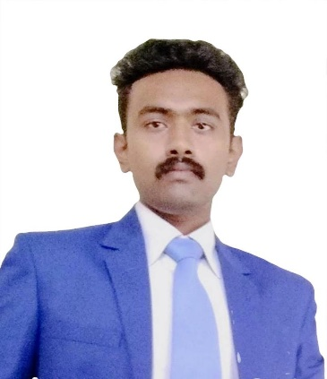
PRASOON GORAI
A versatile and energetic professional in achieving
FOOD & BEVERAGE EXECUTIVE Business growth objectives within turnaround and rapid changing
BANQUETS & RESTAURANT business environment. A determined Food & Beverage Executive with expertise in
strengthening companies to lead in highly competitive situations.

Having 3 years and 1 months of extensive experience in
targeting challenging assignments in Food and Beverages
Operations in areas such as Banquets, Restaurants,
MICE, Weddings and O.D.C.

Contact - +91 – 8825381462
E-mail – prasoong85@gmail.com

PROFILE SUMMARY

A result – oriented professional with a strong, career track in Operations Management - Hospitality and F&B, Client Servicing and Team Management. A consistent performer with a proven track record of increasing revenues and streamlining workflow. Thorough understanding and knowledge of all food and beverage items in the menu and the skills to recommend food & beverage combinations and up-sell alternatives.

SKILLS SETS
- Hospitality Management
- Guest Service Excellence
- Pre – Opening of Hotels and Restaurants
- Hospitality Trainings
- Vendor Management
- Business Sales Calls
- Cost Controls
- Team Building
- People Management
- Positive & Approachable manner

CAREER SUMMARY

Executive – Food & Beverage Department
Mayfair Hotels and Resorts | July ’20 – Currently Working.
Worked as Pre-Opening Team Member
- Responsible for building a well-trained, highly motivated and optimistic team to deliver the requisite
- Responsible for setting up PAR and inventory managing processes
- Certified food handler – set up best practices for food and beverage handling
- Involved in planning and launching food and beverage promotions
- Involved in menu planning with banquet guest.
- Ensuring maximum guest satisfaction by closely interacting with guests to understand their requirements & customizing products & services according to their needs and demands
- Providing training as well as motivating the front line staff to deliver 100% guest satisfaction
- Organizing and conducting practical training programs for enhancing skills and motivational levels of medium to large sized teams with professional backgrounds

Management Trainee
Mayfair Hotels and Resorts | July ‘18 to July ‘20

  - Taking guest’s orders, pick up foods with proper condiments and garnishes and serve guest.
  - Making and settlement of bills
  - Set up tables and side stations
  - Took part in CCG inventory.
  - Prepared breakage reports.
  - Prepared work orders for the vendors to work in designated venues
  - Maintaining vendor records

EDUCATIONAL QUALIFICATION
COURSE | ORGANIZATION | YEAR OF PASSING | BOARD
MATRICULATION | D.A.V PUBLIC SCHOOL | 2012 | C.B.S.E DELHI
INTERMEDIATE | D.A.V PUBLIC SCHOOL | 2014 | C.B.S.E DELHI
B.SC | I.H.M KOLKATA | 2018 | N.C.H.M DELHI

INDUSTRIAL TRAINING
Post – Industrial Trainee
Organization – The Grand Oberoi, Kolkata Duration – 17 weeks

PERSONAL DETAILS

Date of Birth -1st of March 1996
Present Address - Avinash new county Naya Raipur, Chhattisgarh India
Permanent Address -S-Type s-41/7 new housing colony adityapur Jamshedpur-831013

NOTABLE ACCOMPLISHMENTS DURING CAREER

- Merit of successfully OPENING of MAYFAIR LAKE RESORT, Naya Raipur, Chhattisgarh India
- Merit of successfully opening of All - Day Dining Restaurant, TEA-POT
- Merit of successfully opening of Specialty Restaurant, MAMMA MIA
- Successfully planned and executed MENS WORLD CUP HOCKEY EVENT 2019
- Successfully planned and executed ROAD SAFETY WORLD SERIES CRICKET EVENT 2021

HOBBIES

- Motor Cycle enthusiast
- Food blogging
- Cooking

BLOG & WEBSITE

WEBSITE : WWW.TANDOORITRIBE.COM
INSTAGRAM: WWW.INSTAGRAM.COM/TANDOORITRIBE24X7
FACEBOOK: WWW.FACEBOOK.COM/TANDOORITRIBE24X7

REFERENCE

Mr. Shiju Nair
Resort Manager
Mayfair Tea Resort, Siliguri
Contact No. - +91 7017438088

DECLARATION

I Prasoon Gorai do hereby confirm that information given above is true to the best of my knowledge.

Place - Signature-

