CURRICULUM VITAE

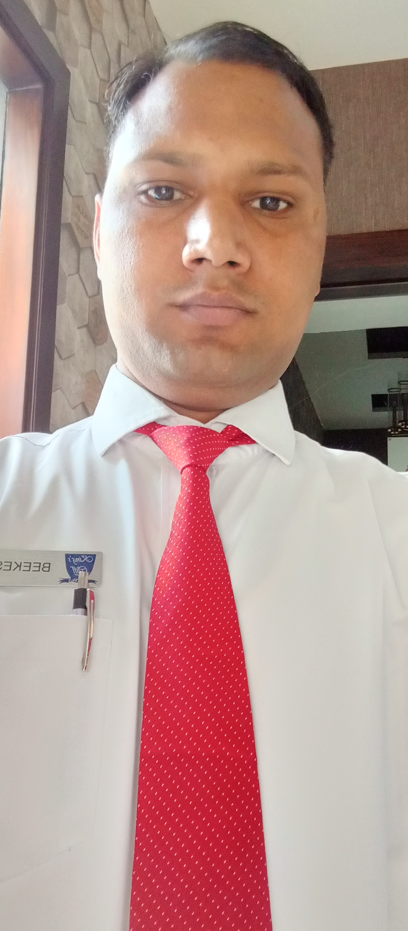

Beekesh singh
Village & Post - Ole
District - Mathura
Pin code - 281122
Mobile no. - +917851003419
Email Id: beekeshk118@gmail.com

CAREER OBJECTIVE
My Career objective is to learn and function effectively in an organization and be able to deliver to the bottom line. To constantly Upgrade my knowledge and skills and to make a difference in whatever I do.

PROFESSIONAL QUALIFICATION
- Completed (Hotel Management) 1 Year diploma From NIHM Bhartpur Raj.

EDUCATIONAL QUALIFICATION
- Completed 12th from U.P board Allahbad in 2010.
- Completed 10th from U.P board Allahbad in 2012.

WORKING EXPERIENCE
- Organization Name : Hotel Shiv Vilas Jaipur
- Designation : Sr.GSA promote
- Duration : 10 August 2017to 10 july 2018
Designation : Captain
Duration : 7 October 2019 to 15 January 2021

Organization Name : Hotel The Fern
Designation : Sr. GSA
Duration : 18 July 2018 to 10 January 2019

- Organization Name : Hotel theme hotel Jaipur
- Designation :. GSA
- Duration : 15 January 2016 to 31july 2017

- Organization Name : Hotel sarovar portico Haridwar
- Designation : Tr.Captain
- Duration : 22 January 2019 to 01 June 2019

- Organization Name : Hotel Indana Palace Jodhpur Raj.
- Designation : Captain
- Duration : 05 June2019 to 05 October 2019

Currently working in : Hotel boulevard9 resort Nadiad Gujarat
Designation : Sr.Captain
Duration. : 20 January 2021 to till date

INDUSTRIAL TRAINING
- Completed Six Month Industrial Training From Hotel royal orchid Jaipur

PROFESSIONAL ACHIEVEMENTS; -
- I have got the winner of fortune Bhartiya Pravashi Divas 2015.

AREA OF RESPONSIBILITIES: -
- Handling Restaurant and Banquet
- Filling up of Daily Sales log book.
- Taking Inventories of CCG.
- Up Selling of Alternate Dining options.
- Responsible for daily Cash closing and guests room postings.
- First and foremost, taking care of guest requirement at outlet allocated.
- Responsible for daily duty allocation.
- Responsible for cordial and proper service.
- Handling guest complain and suggest the guest for food and beverage.
- I have faith positive thinking.

TECHNICAL SKILLS; -
- MS-Office (MS-PowerPoint/MS-Excel/MS-word)
- Internet surfing.
- IDS 6.5,and 7

PROFESSIONAL HIGHLIGHTS
- Self-Confidence
- Punctual
- Good Communication
- Ready to take challenge

PERSONAL DETAILS
Name : Beekesh Singh
Father Name : Devendra Singh
Marital Status : Single
Nationality : Indian
Languages : Hindi & English
Date of Birth : 05 February 1993
Hobbies : Making Friends & Playing Cricket
Permanent Address : Village Nagla Dev Kishan

DECLARATION
I hereby declare that the above mentioned information is correct up to my knowledge and I bear the responsibility for the correctness of the above mentioned particulars.

Date:
Place: (Beekesh singh)

