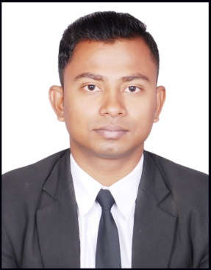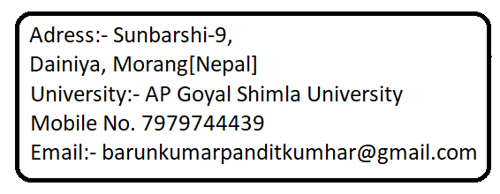
Barun Pandit ______________________________________________________________________________________
OBJECTIVE:-
Looking for a Captian position at ABC company that's incorporates strong interpersonal
Skills when fulfilling a number of customer service task, addressing a wide range of
Needs issues and complaints with ease and efficiency.
CORE COMPETENCES-
- Hard work
- Team work
- Responsibility
- Punctuality
EDUCATIONAL QUALIFACTION:-
YEAR | NAME OF INSTITUE | COURSE | PERCENTAGE  (%)
2014 | Balmiki Secondary English Boarding School | S.L.C  10th | 60.50%
2014-15 | LORD BUDDHA HIGHER SEC.SCHOOL | +2 | 55.60%
2017-21 | A.P.G SHIMLA UNIVERSITY | BACHLOR | Pursuing

TRANNING INDERTAKEN:-
VT done in Mechi kali for 1 month.
4 days ODC in Citrus Resort in Shimla.
Industrial Training (IT):-AT JW Marriot, Jaipur.
Traning Caption on Diyalo Lords plaza (Birgung)

HOBBIES:-
. Planting
- PLAYING CRICKET
- Playing badminton

ACHIVEMENTS:-
Taken part in Kashmiri food fest 2017 in service at APG.
Work on international food fest held in 2019 at APG.
I have done VT in Mechi kali Hotel in Nepal.
Done IT training in JW MARRIOT, JAIPUR.

PERSONAL DETAILS:-
- Name: - Barun Kumar Pandit
- Gender: - Male
- Age: -22 yrs.
- DOB:-1997-02-13
- Blood group: -A+
- Nationality:-Nepalese
- Religion: -Hindu
- Father name: - Shiv Kumar Pandit
- Marital state: - Single

HOBBIES:-
Planting
Listing music

DECLARATION:-
I hereby declare that the information furnished above is true to the my best of knowledges.

Place:- Barun Kumar Pandit.
Date:-

