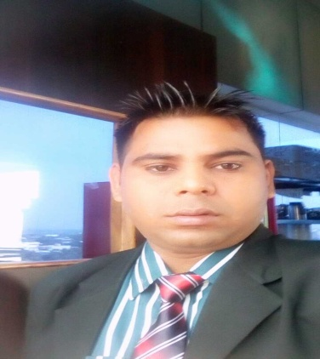

Bablu Kumar Saw

DOB: 1st,DEC. 1989
Address: Nunudih,P.O. Patherdih,Dist. Dhanbad (Jharkhand) 828119,India
Phone91-9386153157 , 9113766332
Email: babluk23@gmail.com
Career Objective: Seeking a position to utilize my skills and abilities in the Hospitality Industry that offers professional growth while being resourceful, innovative and flexible.
Area Of Interest :F&B service department.

Educational History :
I S M PUNDAG RANCHI 2008 TO 2011
Passed 3 years Diploma in hotel managment
J.A.C. Board Ranchi in the year 2007
Passed Higher Secondary Examination.
J.A.C. Board Ranchi in the year 2005
Passed Secondary Examination.
Professional Experience :
Currently working
GRAND UNIARA HERITEG HOTEL JAIPUR
FNB MANAGER 20 may 2018

Grand uniara heriteg hotel Jaipur (Rajasth)
RESTAURANT MANAGER 15 MARCH 2017 TO 12 april 2018

Royal tulip hotel Mumbai (Maharashtra)
As a restaurant manager 7 JUNE 2015 to 10 march 2017

goldenleaf resort in tata jamsedpur jharkhanD
as a f & b executive 20 dec 2014 to 04 june 2015

Taj Getway in chikmagalure
( As a captain in Food & Beverage service) 10 April 2012 TO 8 Dec 2014
Presenting the menu to the guests.
Maintaining the Standards & Quality of the service.
Set up all the Covers as per Tea, Lunch, Dinner.
Set up the buffet of the restaurant.
On a weekly basis Inventory has to done for the stocks.
Taking Orders from the guests.
serving the Guests In the restaurants & in room dining.
.
Taking orders on phone for In house guests at Room service.
Delivery of orders in Rooms as per given time.
Refilling of Mini fridge in the room after the departure of the guests.
Taking food from the kitchen to a restaurant as per guests order.
Conscientious and accurate implementation of the Assistant manager information.
Fortune hotel in ahmedabad (gujrat)
Hotel operation training in Food & Beverage service 06 Oct,2010 To 5 April 2012
Presenting the menu to the guests.
Maintaining the Standards & Quality of the service.
Set up all the Covers as per Tea, Lunch, Dinner.
Set up the buffet of the restaurant.
On a weekly basis Inventory has to done for the stocks.
Taking Orders from the guests.
serving the Guests In the restaurants & in room dining.
Constant endorsement of further sales.
Taking orders on phone for In house guests at Room service.
Delivery of orders in Rooms as per given time.
Refilling of Mini fridge in the room after the departure of the guests.
Taking food from the kitchen to a restaurant as per guests order.
Conscientious and accurate implementation of the Assistant manager information.
Training from Inder Recidency ,Ahmedabad(Gujarat)
As a trainee 1Oct,2009-28Feb,2010
.successfully completed 22 weeks industrial training in all department.
Special Skills:
- Comprehensive problem solving abilities, excellent verbal and written communication skills, ability to deal with people diplomatically, willingness to learn, team facilitator & hard worker.
Certifications &Achievements :.
- I served P.M.of japan in Gujarat.
- I served C.M. of Gujarat.
- I served A.P.J. Abdul Klam Ex.president of india
Personal Details :
- Father name :Devi Saw
- Sex : Male
- Height : 168 cm
- Weight : 63kg
- Nationality : Indian
- Religion : Hindu
- Marital : Unmarried
- Blood Group : O+
- Passport No. : J7150936
Strength :

- Good Communication Skill
- Good Negotiation Capability
- Highly Adaptive, Positive & Hardworking
- Excellent Team Player
- Self Confident

Language Ability :
- English : Fluent
- Hindi : Excellent

