Ajit Kumar Tiwari
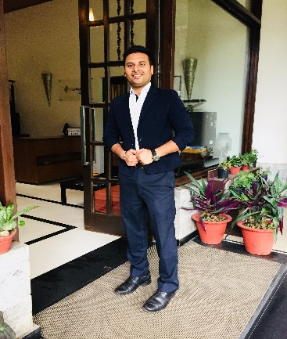  E-mail:  Kumarajit21@icloud.com  WhatsApp number  +917798462896  Permanent Address:  Vill: Hoor  P.O: Hoor  District: Garhwa822114  Contact no.:  Mobile: +91 7798462896  Personal Data:  Date of Birth: 21-12-1997  Gender: Male  Nationality: Indian  Marital Status: Single  Languages: English, Hindi,  Place  of issue - Rachi | Career Objective  A creative & open-minded person with ability to follow instructions and willingness to learn new ideas, management techniques. Successful in building relations with guests, resolving critical problem areas and delivering on client commitments. Excellent communication & interpersonal skills with ability to work in multicultural environment.  Industrial Experience & Work Knowledge  - Worked in THE LALIT GOLF AND SPA RESORT GOA as a CAPTAIN in FOOD & BEVERAGE (2020 till 31.10.2020).  - Worked in Mahindra Holidays & Resorts, in Munnar Kerala as a team leader in Food and Beverage Service (2019 to 2020.)  - Got selected in I Grow program for team leader moved to Jim Corbet (UK) resort, after that South Goa resort (2018to 2019)  - Worked as a Sr. Steward in Food and Beverage Service in Mahindra Holidays & Resorts, Lonavala Maharashtra (2016 to 2018)  - Industrial training from Starling Mac Bengaluru for 6 months.  F & B Operations  - Planning expansive repertoire of menus with chef, along with portion standardization and supervision of food and beverage service.  - Handling all aspects of management including monitoring food service & aesthetic presentation of the buffet.  - Experimenting & presenting innovative ideas, styles and ensuring cost control measures.  - Maintaining quality and consistency of beverages for enhancing satisfaction amongst guests.  - Conducting periodic hygiene audits and conveying feedback to operating staff for gaps in actual Vs standardized norms.  Resource Management  - Handling the daily maintenance of logs.  - Guaranteeing compliance with the standard company specification of beverage recipes and hygiene.  - Training the staff and reviewing their performance as per procedure and company policies.  - Monitoring daily requisition and stock items to meet ideal food cost, formulating record of operating supplies.  Client Servicing  - Ensuring guest satisfaction by achieving delivery of service quality norms.  - Executing system’s policies & procedures to achieve greater guest delight.  - Interacting with clients, handle guests’ requests & resolving service-related issue.  Achievement  - I got a chance to handle the F&B department at club Mahindra Baiguney  - Part of Pre-opening team at Club Mahindra Acacia Goa.

Reports  - Sales program  - Creativity for sales  - Comments Card Analysis.  - Store Consumption.  - Breakage Inventory.  - Daily FnB Activity. Report.  - Daily Sales Report.  - Restaurant Closing Report.  - Banquet Sales and Forecast.  - Liquor Inventory.  - Checklist  - Staff training reports | Professional Education and Training  - Diploma in Hotel Management Catering and Technology, from Silver lining institute west Bengal (2014-2015).  Educational Qualification  - 10th from JAC board (2012)  - Higher Secondary (+2) from JAC (2014)  Reference  Mr. Sharad Yadav: 9960888004  Declaration  I hereby declare that the above-mentioned information is correct to the best of my knowledge and I bear the responsibility for the correctness of the above-mentioned particulars.  Date: - 31.01.2021 Signature:  Ajit Kumar Tiwari

