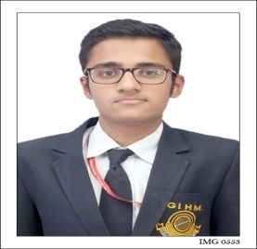
Curriculum Vitae
Abhishek Rana
VPO Binewal Teh.Garhshankar
Dist. Hoshiarpur
Punjab. Pin code 144523
Contact No : +91 9499707461
E-mail : abhishekveetori@gmail.com
_______________________________________________________________________________________________________________

Objective
Looking for global career position in Hospitality Industry that offers challenges, opportunities as well as growth within the organisation where Ican gain more knowledge and skills while contributing my best towards organisation.

Educational Qualification
- Currently pursuing BBA in Hotel and Tourism Management from Dr. Babasaheb Ambedkar Open University at Gujarat Institute of Hotel Management, Vadodara.
- I have completed my 12th from Kendriya Vidayla ONGC Ankleshwar (Guj.).
- I have completed my 10th from Modern Convent School Obra Sonebhadra (UP).

Area of Interest
- Food & Beverage Department

Industrial Exposure
- Done vocational training in Shankau’s Water World Resort Mehsana.
- Participated in Food and Beverage service and Housekeeping, Training organized by Tourism Corporation of Gujarat Ltd.
- I have attended outdoor catering at various properties like ITC Welcome, Grand Mercure Surya Palace, Shanku’s Water World Resort, and Radisson and with caterers like Jay Excellency.
- I have completed my Industrial Training from Fairfield By Marriott, Amritsar (Punjab).
- I have completed my one year in GSA at Fairfield By Marriott, Amritsar (Punjab).
- I am also awarded by Most Diligent Associate of the year.

Strength
- Hard Working
- Helpful Nature
- Good Communication

Hobbies
- Volleyball, Cricket & Listening Music

Technical Skills
- Basic knowledge of computers.

Personal Details

Father’s Name: Ashwani Kumar
Gender: Male
Date of Birth: 30th October, 1999
Languages Known: English, Hindi, Punjabi, and Gujarati.
Marital Status: Single
Nationality: India

