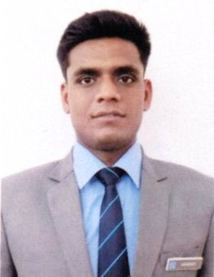
RESUME

ABHISHEK
- Permanent address: H-no 229/5 SANGAM VIHAR NEW DELHI
- Pin code - 110062
- Correspondence address: AZAMGARH UTTAR PRADESH
- Pin code - 276001
- Mobile: +918076590932, 9711122602
- Email: abhishekrai8076@gmail.com

Objective

- To work for company that gives me platform to develop skills set while utilizing my present knowledge.

ACADEMIC QUALIFICATION

- B.sc in hotel Management and Hotel Administration From Institute of Hotel Management Gurdaspur in 2015-2018
- Senior Secondary exam (12th) from GOVT.BOYS SENIOR SECONDARY SCHOOL from CBSE board in 2012.
- Secondary exam (10th) from GOVT.BOYS SENIOR SECONDARY SCHOOL from CBSE board in 2010.

Industrial exposure :

- 4 months industrial training from The Park Hotel New Delhi . I did my industrial training from 06/2016-10/2016. I did my training in all core department like Front office, House keeping, Food and beverage service, and Food production.

Work Experience :
I Worked in ITC Maratha hotel as a Waiter Position (HOST programme) from 10/12/2018-30/11/2020. I worked in In room dining, Coffee Shop, Speciality restaurant,Banquet and also in Butler Service..

Extra curricular activities:
Playing Cricket and Singing

Computer Proficiency

- EXCEL , WORD.

Soft skill

- Hard Working.
- Target Oriented.
- Sincere towards duties.
- Honest.
- Punctual.

Personal Details:
- Father’s Name: Mr. Deena Nath Rai
- Mother’s Name: Mrs. Asha Rai
- Date of Birth: March 01 1995
- Gender: Male.
- Nationality: Indian
- Marital Status: Single.
- Languages Known: English, Hindi
- Height: 6'1
- Weight: 78 kg

Declaration:
- I hereby declare that all the information given above is true.
Place: New Delhi
Date:
Signature

