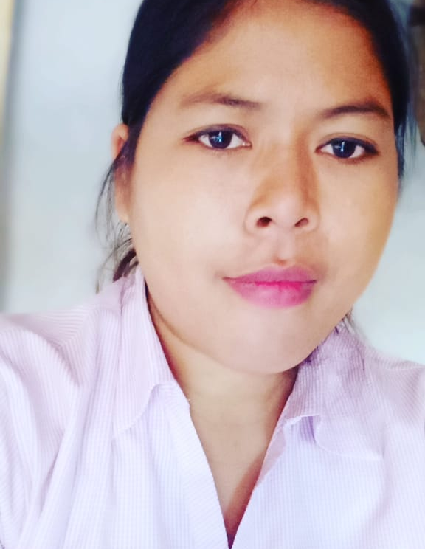
vimla

Address:

Village & P.o.-Belabadh
Mau (U.P)
M. No. 08810378368
E-Mail: vmlahm@rediffmail.com

Career Objective

- To learn and implement the best business practices and to work in innovative and creative field which gives responsibilities and recognition.

Educational Qualification
- Completed B.A from Purvanchal University.
- Completed 12th from C.B.S.E Board Binnaguri
- Completed 10th from C.B.S.E. Board Binnaguri.

Computer Skills

- Fundamental: Basic Knowledge of Operating Systems, MS-Office and Internet.

PROFESSIONAL QUALIFICATION

- I have done 3 Years Diploma in Hotel Management from D.A.V Institute of higher studies, Babatpur Varanasi. .

STRENGTH
- Hard working.

Work Experience

- Presently I am working with mahagun sarovar portico suites ghaziabad from 28th May 2017 to 23 June 2021date as reservations Supervisor .

- Worked with with Optus Sarovar Gurgaon in reservations from 15 Sep 2014 to till 28th May 2017 As a reservation assistant.

- Worked with Fortune Select Excalibur Gurgaon‎ from 05Feb to 14 September 2014 As a front office assistant.

- Worked with Radisson Blue, Greater Noida from 19 Oct2012 to 2nd Dec 2013 As a front office assistant.
- 10 months work with sarovar portico surajkund, Delhi NCR.23 Nov 2011 to 13 Aug 2012a front office assistant.
- I have completed 6 months industrial training from IDEAL TOWER, Varanasi.
- I worked with I DS software and opera software both.
Nature of work :
- Taking checking and checkout.
- Making reservations and handle calls.
- Taking care of cash.
- Taking calls.

Achievement:
- I got the appreciation letter from my general manager because of positive comments through the guest.

Personal Details

Fathers Name : Mr. Shyam Lal
Date of Birth : 20 July
Marital Status : Unmarried
Sex : Female
Nationality : Indian
Religion : Hindu
Languages Known : English, and Hindi
Hobbies : Listening Music & Watching T.V

DECLARATION
I am confident about my ability to work in teem, I hereby declare that the information furnished above is true to the best of my Knowledge.

Date :_______________

Place: _______________

(VIMLA)

