CURRICULAM VITAE
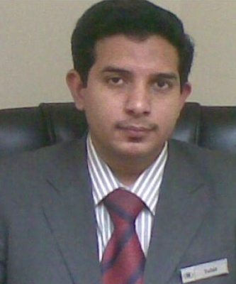
Tufail Ahmad Cell: - 7054941038
mrtufail786@gmail.com

Objective: - To seek challenging avenues where my educational potentials match the organization’s growth, and provide strength to contribute for the achievement of organizational goals, with betterment of my career prospects, and equipping myself with administrative skills
EDUCATION & QUALIFICATION

- Intermediate from UP Board.

PROFESSIONAL QUALIFICATIONS

- Diploma in computer application form UFTEC.
- Computer Software Diploma from Lucknow Polytechnic.
- Diploma in Accounting (Tally) from UFTEC.

COMPUTING SKILLS:
- Accounting (Tally).
- MS Office (Word, Excel, Power Point).
- Internet Operations

Experience in SAUDI ARABIA

I HAVE TEN YEARS EXPERIENCE IN HOSPITALITY AND CORPORATE SECTOR IN SAUDI ARABIA.
- Worked for three years as D.O. (Data Operator ) at Consulate General of India, Makkah.
- Worked for six months in Back Office as Secretary at Makkah Hilton & Tower Hotel.
- Worked for one year in business center as supervisor at Makkah Hilton & Tower Hotel.

Worked for Six years as Office Assistant (Secretary) at Adnan Omar Basalamah Trading Est, Jeddah.

Experience in INDIA
- 1 Year experience in S.A. InfoTech Hardware & Engineer, at Naza Market, Lucknow.
- 1 Year experience as Office Assistant in Gleam Worldwide Express, Lucknow.
- 1 Year experience as a Sales Executive in Info Shopee at Naza Market, Lucknow.

JOB PROFILE:

- Preparing the files for the work orders.
- Maintaining the files for the workers.
- Maintaining the account files for company.
- Managed all mail sent on a day.
- Perfect in internet operations.
- Charming personality and Good Communication Skills (written & spoken)
- Self motivated with a high degree of attention and commitment to work.
- Ability to handle pressure situation good at time management customer service management ability to use positive language.
- Highly responsible, honest and hard working person with the instinct to succeed.

TECHNICAL EXPOSURE:

- Maintenance of PC
- Assembling, Loading programs, Formatting, Installation, and Troubleshooting.

PERSONAL PROFILE:

Fathers Name : Late Mr. Israr Ahmad.

Date of Birth : 7th July 1988.

Nationality : Indian.

Languages known : English, Hindi, Urdu, Arabic. Contact No. : 0091- 7054941038.
E-mail : mrtufail786@gmail.com

DECLARATION
I here by declare that all the details given above are true to the best of my knowledge and belief.
Date:
Place:

Tufail Ahmad

