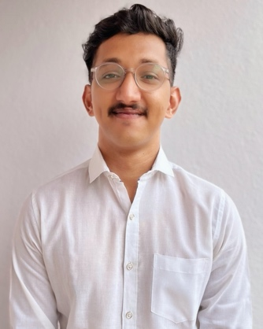
Smit Prashant Kamble
Email: - akshatkamble30@gmail.com
Address: -Building no-3/204 Vijay Park,
Ghodbunder Road, Kasarwadavli
Thane East, Thane, Maharashtra
400615
Phone no: - 9967717093

Personal Particulars:
DOB: -18 October 2002 Age: - 20
Gender: - Male Marital status: - Single

EDUCATIONAL QUALIFICATION: -
Education | Name of Institute | Board/University | Year of Passing
10th | Arya Gurukul | CBSE | 2018
12th | Shri Sidh Thakurnath College | HSC | 2021
Cruise Culinary Program (CCP) | Kamaxi College of Culinary Arts | University of Goa | 2022

Strengths: -
1. Creative thinking skills 3. Adaptability
2. Multitasking 4. Flexibility

Languages known: -
1. English 3. Marathi
2. Hindi

Hobbies: -
1. Sports 3. Traveling
2. Photography 4. Listening to music

Achievements: -
- Participated in 24 hours non-stop skating marathon (Belgaum, Karnataka)
- West zone skating championship winner (Kolhapur Maharashtra, Fatehpur, Rajasthan also Gotan, Rajasthan)
- Goa skating festival open national roller-skating championship winner (Panjim, goa)
- West zone volleyball championship winner (Rajkot, Gujarat)
- National Ball badminton championship winner (Imphal, Manipur)

Experience:-
Hilton Goa resort:- internship (6 months)
In kitchen department (continental)

Upper deck resort :- commis 3 continents and Chinese
Presently working

Speciality in :-
Making hand made pasta
Reference: -
Vinod Kumar -Principal, Kamaxi College of Culinary Arts
Phone No: -90255608010

