SHISHIR KUMAR SAHU
 | At- 4/109, Shree Ganesh Para, Near Petrol Pump, Behind Social Forest Deptt. P.O.-Kuchinda  Dist- Sambalpur PIN-768222  State- Odisha | Mobile no - +91- 7976854928/8107509079  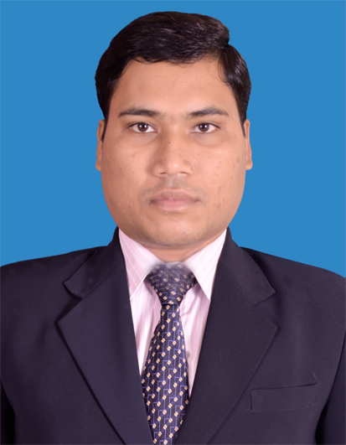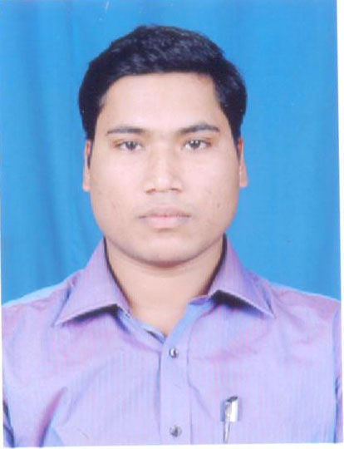  Email –shishirkumar7@gmail.com  sahushishirkumar5@gmail.com

CAREER OBJECTIVE: To seek a career in a professional and competitive environment where hard work, sincerity and initiative is recognized and rewarded. I would like to make best use of my acquired skills and would like to introduce innovation, and contribute to the growth of the firm in every way I can.
QUALIFICATION:
- Completed M.B.A from Sambalpur. University, in 2011.
- Completed 03yrs Degree in B.H.M. from I.H.M. Bhubaneswar in 2011.
- Completed B.Sc (Zoology) from Sambalpur University, in 2005 with 80 percent (70 percent aggregate).
- Completed 12th in Science stream from Kuchinda College, Kuchinda in 2001 with 51 .0 percent.
- Completed 10th from C.S.B.Zilla School, Sambalpur in 1999 with 63.0 percent.
- Completed PGDCA from N.I.I.T., Kuchinda in 2008 with 83.0 percent.
- Completed Tally7.2, 9.0, 9.0 with ERP from Tally Academy in 2008.
EXPERIENCE:
- Worked as Front Office Manager At The Blue Hotels & Resorts, Ahmedabad since Octrober 2018 to May 2021.
- Worked as Duty Manager in Front Office Deptt. At Regenta Inn by Royal Orchid Hotels, Vadodara since February 2017 to September 2018.
- Worked as Front Office Executive in Front Office Deptt. At Fern Residency (A unit of Concept Hospitality), in Jodhpur, Rajasthan since February 2016 to February 2017.
- Worked as Front Office Executive in Front Office Deptt. At Park Plaza Jodhpur (A Sarovar Group Hotel& A unit of Carlson & Rezidor Group), in Jodhpur, Rajasthan since Sept 2014 to January 2016.
- Worked as Front Office Executive in Aveda The Chariot Resort &Spa Puri since June 2013 to Sept 2014.
- Worked as Front Office Supervisor in Hotel Niiki, Sambalpur from May 2011 to May 2013.
Job Profile
- Telephone Handling.
- Guest Relation
- Cash Handling
- Taking Check in & Check out
- Night Auditing
- Tracking late cancellation and no shows
- Handling ‘C-Form’ ( Foreigner Arrival
- Guest complaint handling
- Quick handling of EDC machine.
- Updating FOREX in the system daily basis.
- Checking and verifying reports for the daily transactions.
- Making reservations and sending confirmation for bookings flowing in from various reservation channels.
- Reconfirmation of block bookings and FIT’s.
- Updating reservation with accurate rate / meal plans / arrival & departure details / and with detailed billing.
- Keeping good relation with entire Operations i.e., Front Desk, Security, Housekeeping & F&B etc.

TECHNICAL SKILLS:

- Basics of Computer Applications.
- MS Office, C Programming ,Java, Oracle 9i,.net,C,C++,C++ turbo ,Unix, Linux, FoxPro languages, IDS Next , IDS Version 6.5i,8.0, ADS ,Opera,& Lucid Software& Wish.net & Prologic first.
- Internet Application/Adobe/Ms Outlook
EXTRA CURRICULAR ACTITIVIES
- Event Co-coordinator for various functions in school and college level
- Active Participant of Creative Writing, Seminar, Essay Writing and Science Exhibition
- Completed NCC A, B, C certificates in school and college level.
- Active Participant to represent Odisha Directorate in Republic Day Camp in New Delhi.

PERSONAL SKILL:
- Determined, Responsible
- Hard Working and Dedicated
- Possess analytical skills and innovative ideas
- Good people skills
SOFT SKILLS
- Good Inter-personal Skills
- Team-building
- Willingness to Learn
HOBBIES:
- Listening to music.
- Reading books
- Playing Cricket
- Chatting with friends.
STRENGTH:
- Good Team Player
- Problem Solver
- Goal Oriented
WEAKNESS:
- Open, Direct Straight forward in my approach.
- I can’t say no to people.
- I m get emotional by situation.

PERSONAL PROFILE:
Name Mr.Shishir Kumar Sahu
Father’s Name Mr. Jayakrishna Sahu
Mother’s Name Mrs.Renubala Sahu
Date of birth 02nd August1989
Marital Status Unmarried
Gender Male
Nationality Indian
Languages Known
(Reading, Writing and Speaking) English, Hindi and Oriya

Permanent Address At- Kuchinda, P.O.-Kuchinda
Dist- Sambalpur PIN-768222
State- Odisha
Passport No. R1895425

Skype ID shishir885

REFERENCE
On Request

DECLARATION
I hereby declare that the above information furnished is true to the best of my knowledge and belief.

Place : Ahmedabad Shishir Kumar Sahu
Date : 09.10.2021 SIGNATURE

