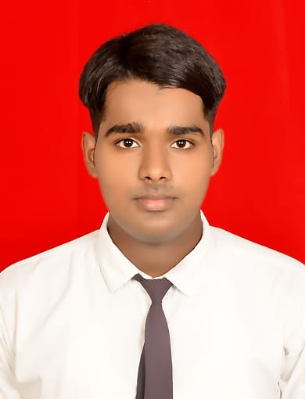
SARTAJ
Address: - Mohalla Muftisarai Chandpur
Distt: - Bijnor, (U.P) 246725
Contact No: - 9917601448
E-mail:- mohdsartaj216@gmail.com

Specialization Bakery & Confectionary

Carrere Objective:-

To be a part of an enthusiastic work environment, where I can enhance my knowledge and apply my technical skills to accomplish organizational goals.

Skill: -
- Good Communication
- Quick Learner
- Basic Knowledge About Kitchen
- Innovative
- Good Presentation Skill Confidence
Academic Background
Year | Course | Name Of Board / University | Percentage
2021 | DBC | Food Craft Institute Aligarh | 70%
2018 | XII | UP BOARD | 54%
2016 | X | UP BOARD | 60%

Industrial Training: -
  - Successfully completed industrial training form Hotel Royal Orchid Jaipur from 06 Oct 2020 to 05 April 2021.
Best Trainee of the month.
F&B protections.
F&B service.

Hobbies: -
- Cooking
- Traveling

Co-Curricular Activities: -
Participate in sports activity, competition and hospitality event.

Personal Information: -
Father’s Name: - : Gulfam
Gander: - : Male
Date of Birth: - :16/05/2001
Religion: - : Muslim
Nationality: - : Indian
Marital Status: - : Unmarried
Language Known: - : Hindi & English
Declaration:
I hereby declare that all the details furnished above are true to best of my knowledge and belief.

Place: ………………………
Date: ……………………….

(Sartaj)

