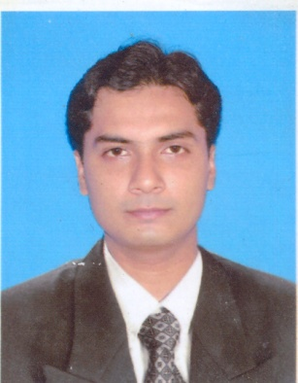
SAON DEB
HABRA
24, PARGANAS (NORTH)
Mobile: 9332358642
E-mail: saon_sanku@yahoo.co.in
saon_sanku@rediffmail.com

PROFILE
I am a Hotel Management personnel with 14 years of experience in the Hospitality Industry. My current job profile is that of an Sales Manager-Sales & Marketing, which involves direct interaction with the guests as well as office co-ordination activities. Meeting budget. Coordinating with Operation. Taking guest Feedback. Generating new & repeat business.

WORK EXPERIENCE

Company Radisson, Kolkata

Company Profile A Five star deluxe property situated at Gariahat, Kolkata-700017.

Tenure July 2019 – Till date

Worked As Senior Sales Manager.

Company The Lalit Great Eastern Kolkata

Company Profile A Five star Luxury property situated at Dalhousie , Kolkata-700069.

Tenure March 2018 – June 2019

Worked As Sales Manager.

Company Park Plaza, Kolkata(Carlson Rezidor)

Company Profile A Five star deluxe property situated at Gariahat, Kolkata-700017.

Tenure January 2014 – February 2018

Worked As Sales Manager.

Company Hotel Hindustan International, Kolkata

Company Profile A Five star deluxe property situated at A.J.C. Bose Road, Kolkata-700017.

Tenure August, 2012– December 2013

Worked As Assistant Manager Sales.

Company Chrome Hotel (Chocolate Hotels Pvt. Ltd.)

Company Profile Chrome Hotel Four star deluxe property situated at A.J.C. Bose Road, Kolkata-700017.

Tenure June, 2011– July, 2012

Worked As Assistant Manager Sales.

Company Hotel Hindustan International, Kolkata

Company Profile Hotel Hindustan International is a five star hotel located in Kolkata.

Tenure March 2009 – April 2011.

Worked As Executive sales.

Company Hotel The Peerless Inn

Company Profile Hotel The Peerless Inn is a Four star property in Kolkata.

Tenure January, 2008– February, 2009.

Worked As Executive sales.

Company Hotel The Park Vizag

Company Profile Hotel The Park Vizag is a five star hotel located in Vizag.

Tenure March, 2004 – December, 2007.

Worked As Captain.

EDUCATION
- 2001-2004 NIPS School Of Hotel Management(AICTE approved)

- 2001 Passed Higher-secondary from Hatthuba Adarshya Bidyapith.

- 1999 Passed Madhyamik from Hatthuba Adarshya Bidyapith.

PERSONALDETAILS

- Age : 37 years

- Height : 5’ 10”

- Languages Known : English, Bengali, Hindi

- Sex : Male

- Marital Status: Married

STRENGTHS

I have positive attitude–as a quick learner and dynamic in adapting to change. I have good interpersonal skills with a huge Database. I believe that these strengths will help me in being a great resource for your esteemed organization.

INTERESTS
I love listening to music & playing football.

Date:……………….. Signature. ..…………….

