Resume
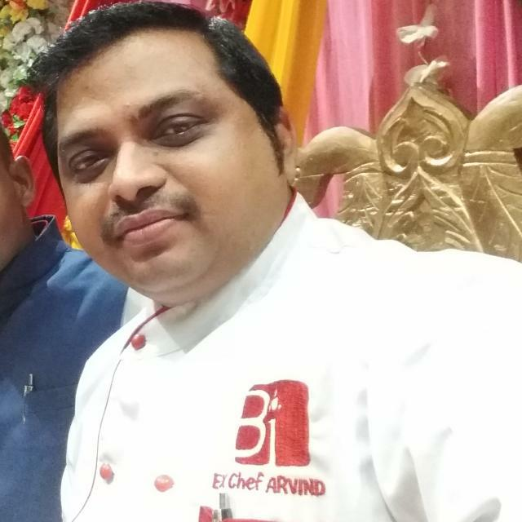
Arvind Kumar
Father Name: Mr Shiv Narayan Raut
Present Address: Gisara
P.O: - Gisara
P.S:- Parsauni
Dist: - Sitamadhi
Bihar: - 843311
Mob No.: - 8877171259
Mail ID: - chef.arvind@yahoo.com
Career Objective
I am quite young and energetic and am looking forward to a better job prospect/ opportunity and better remuneration and offering myself a suitable position in your organization.
Educational Qualification
- High School passed from Bihar Board Year 2001.
- Intermediate passed from Bihar Board in 2003.
Working Experience
- One Year Experience Ritz Continental Lucknow as a Commi 3rd (2005 to 2006)
- Two Year Experience I.C.H Lucknow as a Commi 2nd year (2006 to 2008)
- Two Year & Six Months Experience Food Plaza Mumbai as a commi 2nd year (2008 to 2010)
- One Year Four Months Experience Comfort Inn (By Choice Group) Hotel Lucknow as a Commi 1st (2010 to 2012)
- Eight Months Experience Tulip Inn (Chain Group Lucknow as a Commi 1st year 2012
- One Year Experience as a D.C.D.P in Hotel Rivatas by Ideal Varanasi Oct (2012 to 2013)
- Worked with Buddha Group of Hotel, Patna as a Sr C.D.P from 1st Aug (2013 to 30/05/2015)
- Worked with at PindBulluchi Patna as a Sr. C.D.P (Revolving) from 24/06/2015 to 05/07/2016
- Work with at Food Universal (Masala Cottage Nepal as a Head Chef from 07/07/2016 to Nov 1st 2018)
- Three years of work experience at Hotel Buddha Imperial Muzzafarpur Bihar as an Executive Chef year 06/11/2018 to 11/12/2021.
- Worked with chhappan Bhog multi-cuisine restaurant Patna as a unit Head chef from 20/12/2021 to 15/08/2022.
- Recently working with at Hotel Sapphire Inn Siwan Bihar as an Executive Chef from 26/08/2022 to till date.
Personal Detail
Date of Birth : 26.10.1984
Gender : Male
Marital Status : Married
Nationality : Indian
Language Known : Hindi & English
Religion : Hindu
Declaration
I hereby declare that all the statement made by me in the Bio-data is true and complete in the best of my knowledge.

Date: ……………………………………… Signature: ………………………………………

