CURRICULUM VITAE
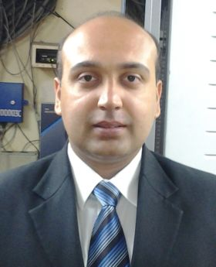

RICKY BHATT
A-5/B-265, PaschimVihar,
New Delhi-110063
Tel: - 011 – 25275596 (R)
+91 8368608862/9910167662 (M)
E-Mail – rbhatt8190@yahoo.co.in
______________________________________________________________
WORK EXPERIENCE:
- Worked as a Front Office Manager in James Plaza Hotel Chandigarh from June 2018 – November 2020.
- Worked as a Duty Manager in ITC Fortune Select Global Hotel, Gurgaon from July 2010 – June 2018.
- Worked as a Duty Manager in The Park Turon Hotel, Tashkent (Uzbekistan) from August 2009 – April 2010.
- Worked as a Front Office Faculty with Jagannath Institute of Management Sciences (JIMS), Rohini from January 2009 – August 2009.
- Worked as a Lobby Manager in The Park Hotel, New Delhi from February 2008 – January 2009.
- Worked from May 2004 – February 2008 in the Radisson Hotel, New Delhi.
- Joined Radisson Hotel, New Delhi as a Front Office Assistant in May 2004.
- Promoted as a Front Office Executive in April 2005.
- Promoted as a Senior Front Office Executive in April 2006.
- Promoted as an Assistant Manager – Front Office in April 2007.
- Worked from Sept.2003-May 2004 as a Front Office Assistant in the Qutab Hotel, New Delhi.
EDUCATIONAL QUALIFICATIONS:
- A Three-Year Diploma in Hotel Management (1998-2001) from Institute of Hotel Management (IHM), Pusa, New Delhi.
- Passed Senior Secondary from Ram Krishan Kulwant Rai Public School, New Delhi in 1998.
- Passed Higher Secondary from Ram Krishan Kulwant Rai Public School, New Delhi in 1996.

PERSONAL DATA:
DATE OF BIRTH : 07.08.1980
FATHER’S NAME : Mr. Vijay Bhatt
MARITAL STATUS : Married
PASSPORT NO. : K7985790
LANGUAGES KNOWN : English,Hindi,Gujarati

(RICKY BHATT)

