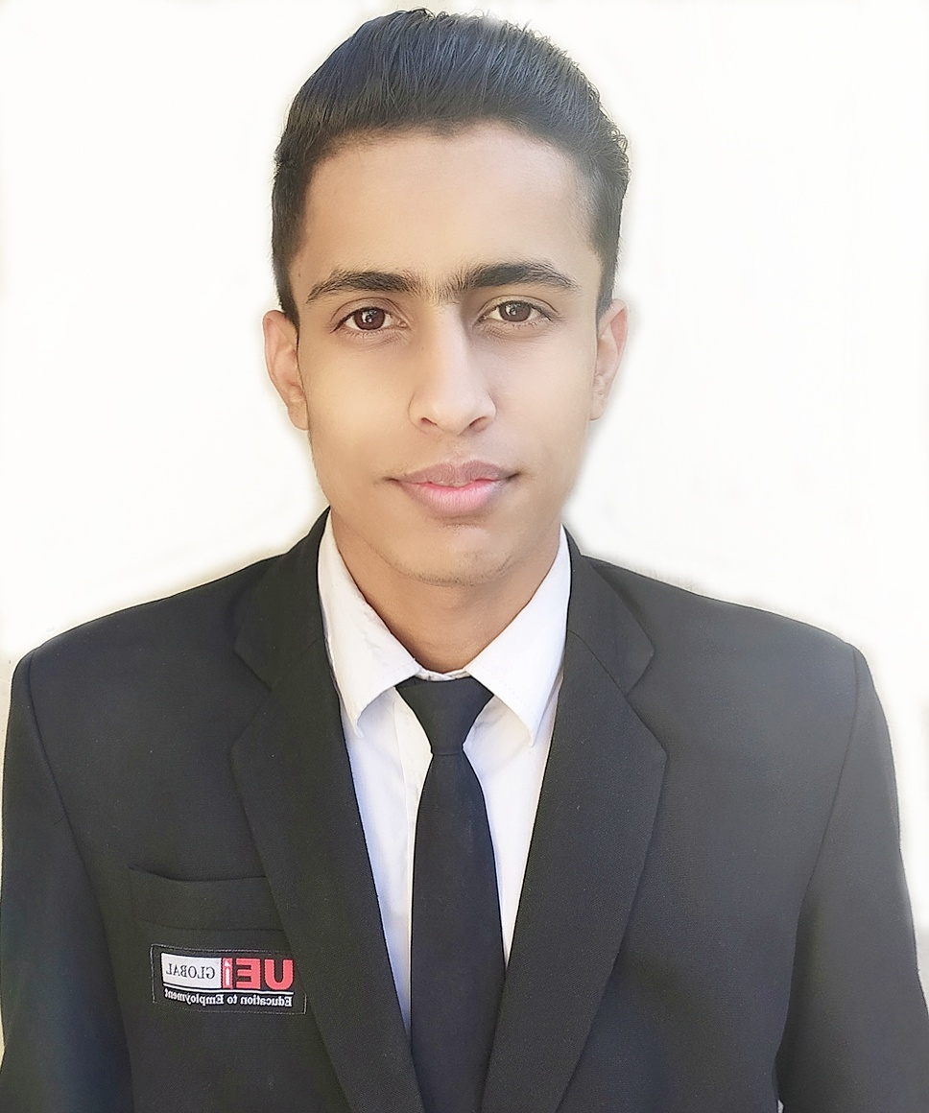
RAHUL KADYAN
Address: Rithala, New Delhi-110085
Contact : +919588336349
E-mail address: Rahulkadyan56mail@gmail.com

CAREER OBJECTIVE:

- Excellent communicator with an strong desire to learn, looking for work with an organisation that would give me an opportunity for personal growth and enhance my professional skills in the service industry.

QUALIFICATION:

- Pursuing B.Voc Degree in Tourism & Hospitality from Mangalayatan University through (UEI Global, New Delhil).
- Passed 12th from CBSE Board New Delhi
- Passed 10th from CBSE Board New Delhi

INDUSTRIAL TRAINING:
- I have completed my industrial training from Crowne Plaza Rohini, New Delhi & it is a IHG Brand and famous hotel in all over India.
- I got a chance to work in all four core departments of the hotel and to enhance my hospitality skills.
- During my internship, I tried to understand that how the Concierge desk works in the front office department and got a very good exposure.
- During my internship in front office department, i got a chance to learn that how P.M.S works and what are the procedures of check-in, check-out , Night audit, key making. And i lean some other types of works related to back office.
- During my internship in front office department, i got a chance to work as a bell boy and got a chance to understand the duties and different types of tasks of a bell boy, which will help me to enhance my professional skills in hospitality industry.

INDUSTRIAL EXPOSURE:
- Assisted in Front Office Department in the below hotels
- Oberoi Maidens, New Delhi
- JW Marriott, New Delhi
- The Roseate , New Delhi
- Hyatt Regency, New Delhi
- Crowne plaza, New Delhi
- Novotel Pullman, New Delhi

ACHIEVEMENTS:
- During my 1st year, i was recognised as the most regular student in my college and i got a 100% attendance certificate.
- I assisted many VIP peoples from various companies at front desk in CII event and i got a certificate
- Participated in National Sports and Cultural Festivals Le Vitesse 2020.
- participated in online wine education course and i won a certificate.
- Participated in various events like
•Cover setup
•Chef competition
•Napkin folding
•Flower arrangement
•Food stall
•Diya Decoration
- Participated in Creative Art competition held by UEI Global and got 2nd prize

HOBBIES/INTERESTS
- Travelling
- Writing poems
- Singing
- Chess
- Making mocktails

PERSONAL DETAILS:

Father’s Name - Satbir
Language Known - English , Hindi & Basic french
Height - 5’8
Weight - 55kg

REFERCENCES:
NAME : Ms. Ritu Sharma
ORGANIZATION : UEI GLOBAL INSTITUTE
DESIGNATION : Deputy Director - Academics
CONTACT NO. : 9818724190

NAME : Mr. Anuj Tyagi
ORGANIZATION : UEI GLOBAL INSTITUTE
DESIGNATION : HOD – Hospitality & Placements
CONTACT NO. : 9711480964

Sign :
Place: New Delhi.

