Pragati Patankar
gmpragatigm3579@gmail.com
7020873402
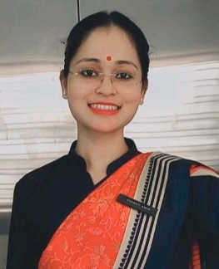
CAREER OBJECTIVE

To enhance my working capacities, professional skills, business efficiencies and to serve my organization in best possible way with sheer determination and commitment.

AREA OF INTEREST

Front office

PERSONAL DETAILS

Address flat no. 101, GR towers, shaba colony, puppalguda, Manikonda Date of birth 03/03/1999
Gender Female
City Hyderabad
State Telangana
Pin Code 500089
Nationality India
Marital Status Unmarried
Religion Indian
Languages known English, Hindi, Marathi
Hobbies Reading Novel, Watching Web series, Cooking

WORK EXPERIENCE

Industrial Trainee Trident Hyderabad Jul 2019 - Oct 2019

Hyderabad's top rated 5 star deluxe hotel on Trip advisor, the hotel has 323 rooms and suites with 3 restaurants, Bar, Club Lounge, Business Center, Boutique Shop, Fitness Center and Swimming Pool. Trident Hyderabad is a part of Oberoi Hotels and Resorts. Being a trainee It was my first exposure to the practical operations of hotel industry. Here I have worked in close association with Front Office, Housekeeping, Food and Beverage Service and Food Production.

Degree/Course | Institution | University/Board | CGPA/Percentage | Year of Passing
B.Sc. In Hospitality And Hotel Administration | National Institute Of Tourism And Hospitality Management | NCHMCT | 1st yr.- 77.27%  2nd yr.- 78.32%  3rd yr.- pursuing | 2021
12th | Heda Jr. College, Washim, Maharashtra | Board | 72.46% | 2017
10th | Happy Faces School, Washim, Maharashtra | Board | 81% | 2015

EDUCATION DETAILS

SKILLS

Communication skills
Smart working Interpersonal skills
Team Building Attention to detail

ACHIEVEMENTS

Kudos card Received kudos from team Kanak for my work during training.

DECLARATION

I do hereby declare that the above given statements are true and correct to the best of my knowledge.

Pragati Patankar
Place: Hyderabad

