RESUME
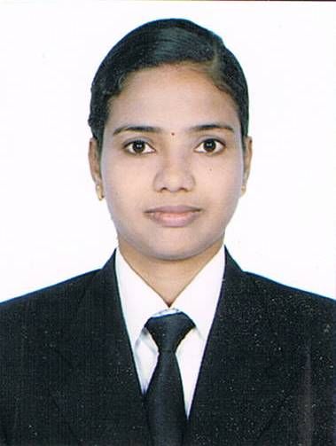
Ms.A.R.Madhusmita Palita
AT/PO:-Bhadrak
Dist.:-Bhadrak
Orissa, Pin:-756127
Ph:-08249159765
07899083501

Email id:-armadhusmitapalita@gmail.com

CAREER OBJECTIVE:-
I intend to reach heights by working as key player in the challenging environment where my Knowledge and potential can be utilized in the best interest of organization and me as an individual.

STRENGTH:-
- Effective Communication Skill
- Self Confidence
- Leadership Quality

ACADMIC QULIFICATION:-
- +3 pass 85% Degree in central Institute of hotel management and catering (CIHM) Utkal University of culture.
- +2 pass 60% B.N.M.A.College Paliabindha, Bhadrak.

- 10th pass 65% Ramnarayan high school,Dolsahi,
Bhadrak.

PROFESSIONAL QULIFICATION:-
- +3 pass 76% Hindi, Wardha Centre, Nagpur.
- P.G.Pass 89% Hindi, Wardha Centre, Nagpur.

COMPUTER SKILLS:-
- Basic Course In Computer(PGDCA)
- Internet and Web Designing.

CURRENT EMPLOYMENT:-
- Presently working in Gardeenia Comfortes, Bangalore as a Duty Manager from 01stApril 2017 till to date.

PREVIOUS EMPLOYMENT:-
- Worked as a Sr.Front Office Executive in Svenska Design Hotel,Bangalore from 26th March 2015 to 27th March 2017.

- Worked as Guest Relation Executive at La Classic Hotel,Bangalore from 12th Mar 2013to 9th March 2015.

- Worked as Front office Supervisor at Park Plaza Hotels,Coimbatore from 02ndFeb 2011to 10th Mar 2013.
- Worked as Guest Relation Executive at Sterling Holidays,Kerala from 20th Jan 2009 to 30th Jan 2011.
- Six Months Training at Ramji film city (Dolphin group of hotels) Hyderabad.
ACHIEVEMENTS:-
- “Best employee of the month “awards for month of October 2019 from “Gardeenia Comfortes Hotel”

- “Best employee of the month “awards for month of October 2018 from “Gardeenia Comfortes Hotel”

- “Guest Champion Award “from Gardeenia Comfortes Hotel.

- “Guest Champion Award”from Sevenska Design Hotel.

- Treated clients and customers with professionalism and with a friendly attitude and kept them coming back.

- Best Executive of the month “Award for month of March 2012 from Park Plaza Hotel”Coimbatore.

PERSONAL INFORMATION:-

Fathers Name : Mr. Amiya Kumar Palita
Date of Birth : 31st May 1987
Gender : Female

Hight : 5.9ft

Weight : 55kg
Nationality : Indian

Religion : Hinduism

Languages : English, Hindi, Oriya, Tamil, Telugu, Kannada

LEISURE INTERESTS:-
- Listening to music
- Surfing Internet
- Reading the novels
- Interact in with People

REFERENCES:-
- Mr. Vinay Chathrubady@Sterling Holidays.

- Mr.Balaji(hrmanager@vivanta by taj coorg)
Mob No:-+919008434400

DECLARATION: - I hereby declare that all the information given above is true to the best of my knowledge and belief.

Date:-

Place: - Ms.A.R.Madhusmita Palita

Signature of Applicant

