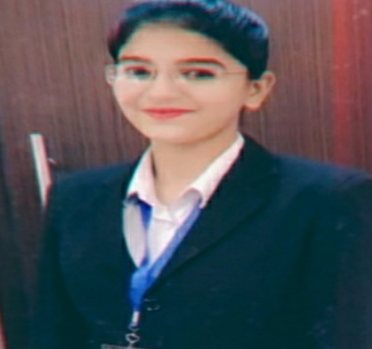
RESUME
Name- Miss Lakshita
Address- H no.425/13, Street no.8,
Goal Masjid, Sharifpura, Amritsar.
Contact no- 8872726042
Email ID- sharmalakshita973@gmail.com
OBJECTIVES
- To adapt to the working environment and deliver my expertise in the innovation hospitality skills, while maintaining the integrity and work ethics, thereby keeping up the reputation of the organization.
ACADEMIC QUALIFICATION
Class | Passing Year | Institute/board | %age
10th | 2015 | PBSE | 71%
12th | 2017 | PBSE | 78%
B.Sc ATHM | 2020 | PTU | 84.5%

COMPUTER SKILLS
- Basic knowledge of computer.
EXPERIENCE
- I have done vocational training from humbal Una hotel in all department.
- I have done 3 month leap programme from holiday inn hotel in front office department.

- I have done 3 month industrial training from Hilton Jaipur at front office department.
. I am doing job in front office department from urban galaxy hotel in Amritsar
Languages Known
- English
- Hindi
- Punjabi

PERSONAL PROFILE
Father’s Name | Mr. Surinder Sharma
DOB | 29/12/1998
Gender | Female
Nationality | Indian
Marital Status | Unmarried

DECLARATION
The information given by me is true to the best of my knowledge and faith.
Date:
Place: Amritsar
Signature:

