Duty Manager
Hotel professional with Seven years of working experience in the hospitality industry. In depth knowledge of maintaining high
standards for overseeing front desk operations.
Hands on experience in evaluating guest satisfaction levels and working toward continuous support.
Industry Preference: Hospitality/Travel/Tourism
Profile Summary

● Hospitality Professional with over 0 8 years of experience in Various Departments :
Hotel Reservations & Revenue Team Management Cashiering
Front Office Operations Learning & Developments OTA’s handling
Conflict Management
- To ensure a smooth and efficient running of the hotel operation with particular focus on the front office department- Reception, Reservations, Concierge, Guest Relation and Travel Desk.
- To assist in maintaining and developing agreed operating procedures involved in the Front Office and to ensure that Front Office colleagues adhere to the correct procedures as laid down in the operating manuals.
- To set a high example in regard to punctuality, appearance, performance, attitude, leadership, guest relations, observations of the house rules and interdepartmental co-operation.
- Evaluates team in order to identify training needs and ensure all the identified training plans are carried out.
- Manage and motivate all front office personnel with daily supervision to include staffing, training, discipline, scheduling and visually monitoring performance to ensure adherence to all service and productivity standards to provide guest satisfaction.
- All pre-opening tasks and responsibilities as per pre-opening plan.
- Meeting various company representatives and showing around them the property.
- Responsible for the daily operations and smooth functioning of Front Office Department.
- Participating in weekly ‘market review’ meetings, maintaining month's running inventory and rates, analyzing weekly reports.
- Working with the Revenue Manager to analyze market segments and devising strategies to maximize low producing segments.

Areas of Expertise
- Strong negotiation, analytical, strategic & creative problem solving skills
- Good image & excellent communication & interpersonal skills, over email or phone
- Demonstrated ability to thrive in a fast paced environment while managing multiple projects & tight deadlines
- Ability to work independently as well as within a team.
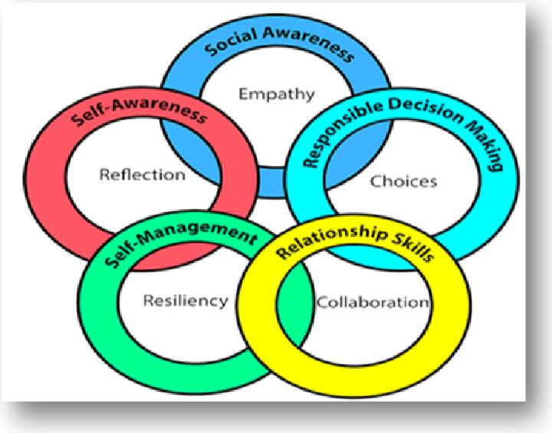
- Ability to conduct articulated, focused and inspiring conversations with both corporates and travel agents, in order to deliver our value propositions.
- Willing to travel, take on commercial challenges, and think outside the box
- Fluency in both spoken and written English & Hindi.
- Ensuring inventory levels exceed demand throughout the market, ensuring rate competitiveness
- Identify and negotiate with key partner's preferential conditions in direct coordination with the immediate superior & promote the commercial opportunities.


Rajasthali Resort & Studios Limited Duty Manager-July 2 0 1 8 till Jan 2 0 2 0


Work Experience
The Saneer Hotel Jaipur,Rajasthan Property Manager- July 2 011-July 2 0 1 8
Days inn by Wyndham
Duty Manager-Jan 02till present
Key Result Area:
Taking care of hotels day to day operations.
Taking care of learning and development needs of associates
Hands on working experience of using channel Manager Axis rooms ,Ezee centrix And Staah Managing inventories and rates on online platforms
Leading and coordinating with back office team for smoother operations

Education

2 0 1 1 Diploma in flight steward and ground handling from paramount airways training academy Jaipur
th
2 0 1 0 1 2 from CBSE Board, New Delhi India
th
2 0 0 5 1 0 from CBSE Board, New Delhi India

IT Skills

● Proficient with MS Word, Excel, and PowerPoint

Personal Details

Date of Birth: April 0 2 , 1 9 8 9
Languages Known: English, Hindi
Address: 7/1 5 2 Sector 7 Malviya Nagar Jaipur

