Akash Sharma
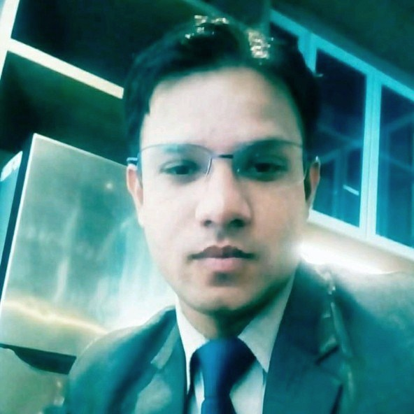
- Vill:Ujarai Kalan, Po:Malupur
- Agra, Uttar Pradesh, 283126
- +917610017400|sharmaakash645@gmail.com

profile

Coordinating As Assistant front office manager more than 2.5 years of experience working for high-end hotel chains. Diligent team player committed to providing exceptional guest services by directing staff, managing individual and group bookings and resolving common customer service issues. In-depth knowledge of hospitality industry and business administration.

Experience
VIVIDUS BANGALORE (108 keys) BANGALORE
Asst Front Office Manager May 2019 – Present
Job & Responsibility
- Implemented new training programs for administrative personnel on office operations and latest technologies.
- Kept physical files and digitized records organized for easy updating and retrieval by authorized team members.
- Tracked and recorded expenses and reconciled accounts to maintain accurate, current and compliant financial records.
- Enhanced collaboration between team members by preparing meeting materials and taking clear notes to distribute to stakeholders.
- Always cross check and updated all OTAs and individual extranets and keep updates.
- Encouraged and mentored employees to boost performance and remove process inefficiencies.
- Protected staff and customers and minimized legal issues by quickly resolving safety issues.
- Recommended strong business plans, operational decisions and financial processes to support business sustainability.
- Enhanced revenue and gross profits by eliminating waste and maximizing customer satisfaction.
- Directed and motivated office staff to deliver exceptional internal and customer support in WIN HMS/IDS setting.
- Reduced customer issues by 90 % with introduction of surveys and questionnaires.
- Acted as point of contact for vendor collaboration for contracted services.
- Produced high-quality documents, spreadsheets and presentations for internal and customer-facing needs using MS Office suite.
- Drafted employee work schedules to fill coverage gaps.
- Supervised payroll corrections for accuracy and duplications.
- Organized international and domestic travel arrangements for up to 21 staff members, including all transportation and hotel stays.
- Interacted with customers professionally by phone, email or in-person to provide information and directed to desired staff members.

The Fern Residency Somnath (56 keys) Somnath
Asst Front Office Manager Oct 2018 - May 2019

Grand o 7 (160 keys) Ahmedabad
Sr Duty Manager Manager Dec 2017 - Sep 2018

Effotel By sayaji (180 keys) Indore
Front Office Executive Apr 2017 – Dec 2017

Aakar lords INN (60 keys) Saputara
Asst Front office Manager Jan 2016 – April 2017

NOORYA HOMETEL (SAROVAR HOTELS) (117 keys) PUNE
Tr. Front Office Executive Nov 2014 - Jan 2016

Regenta Central (Royal Orchid)(58 Keys)jAIPUR
Front Office Supervisor Feb 2013 - July 2014

Marc royal (44 KEYS) chandigarh
Front Office Assistant Apr 2010 - Feb 2013

Cama hotel ahmedabad
INDUSTRIAL TRANING July 2009 –Dec 2009

Education
St merry's public High School High School, U.P BoardScience stream 2005
Jagdambha Inter college Intermediate, U.P Board Science stream 2007
A I H M Agra 3 Year BHM, Affiliated With Bharathiar University 2008- 2011.

Software Skills
Win Hms
IDS 4.2, 6.1, 6.5
Host Win
Power HMS

Personal detail
Father’s Name Mr. Ashok Sharma
Date of Birth 12 May 1992
Gender Male
Marital Status Married
Nationality Indian
Higher Education B.H.M from AIHM Agra (Degree)
Area of interest Front Office

I Here By Declare That Information Furnished Above Is True to Best of My Knowledge & Behalf
Date – Thanking You
Place – (Akash Sharma)

