CURRICULUM VITAE

VIJAY PRAKASH
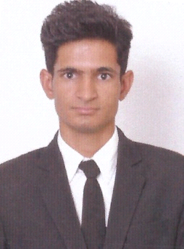
Date of Birth: 1st July 1998
Permanent Address:Vill:- chhajoli, Teh.-Jayal
Dis.-Nagaur, Rajasthan,Pin. -341023
Mob No. - +91 -7023528658
Email ID: bidiyasarv@gmail.com

Educational Qualifications:
Year Qualifications Institute/School
2016-2019

Completed B.Sc in Hotel Management The Trident Institute of Hotel
Kuchaman City

2016 10+2 Tagore Sr. Sec. School, Jayal

2014 10th Tagore Sr. Sec. School, Jayal

Profile:
I am a calm and hard working person with great ability to handle stress in situations. I love working in situations which test my abilities. Have a passion for providing the highest standards of hospitality and service to the guests. A quick learner who can absorb new ideas, communicate clearly and also find suitable solutions to meet the needs of the guest.

Skills and Interests:
- Operating skills: Basic Computer Knowledge
PMS: 1. Opera PMS Knowledge
2. IDS PMS Knowledge

- Chemicals: Knowledge Of All chemicals use in Rooms

- Handover : Take or Give Handover to Next Shift Properly via Handover Register

- Take Care of Master Key :How to Handle Master Keys and When Access. When We lost How to Make New via Proper Procedures

- Consumption :Supplies

- Inventory : of Rooms Items, Electronics Items

- Languages: English and Hindi.

- Interests: Driving, Cricket.

Experience:


- I’m Working in Ramada By Wyndham, Bengaluru Yelahanka As a Floor Supervisor From 10th February, 2021 to Till Date.


- I’m Worked in Radisson Blu Resort Fujairah (UAE) As Senior Room Attended or Self Checker from 31st January, 2019 to 3rd February, 2021
- Reference-:
- Chanderkant Sharma
- Executive Housekeeper ,Radisson Blu Resort Fujairah
- Mob. -: +91 -7807133447

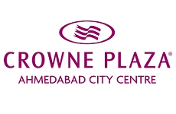
- I’m Worked in Crowne Plaza Ahmedabad City Centre as Housekeeping Associate From 2nd May, 2018 to 15th January, 2019

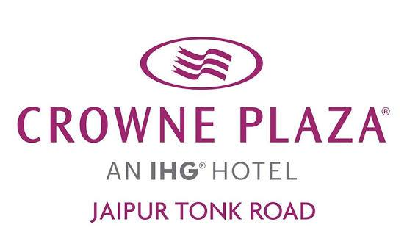
- I have done 6 Month Industrial Training(IT) From Crowne Plaza Jaipur Tonk Road From 19th June, 2017 to 22nd November, 2017


- 30 days Vocational Training from The Club Mahindra Varca Beach Goa, India.

Declaration:

I hereby declare that all the above information provided by me is true to my knowledge and it has been furnished in my complete consciousness.

(Vijay Prakash)

