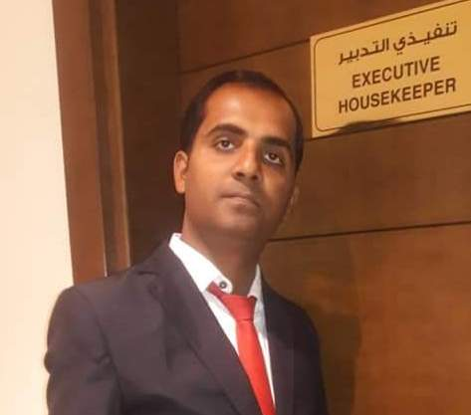 | Utsav Madhav Jha  Profile Summary
Over 11-Years of experience in House Keeping Management
Well Knowledge in House keeping department.
Good Experience in customer complaints handling
Summary of Skills
Able to work under pressure and possess effective communication Skills. Actively participated in extracurricular activities during university career and enjoy teamwork. Able to taking up early responsibility, not losing hope even in extreme Darkness.
Academic Skills
utsavmadhav968@gmail.com
 Utsavjha06478
+91 8521182339
+968 95060832
 DOB -9th Nov 1987.
 INDIAN / L8993545.
BIHAR –INDIA

B.Sc. in Catering Science & Hotel Management, A.S.T.H.A , West Bengal | 2010
H.S.E from Ram Mohan Roy Seminari College Patna | 2006
S.S.C from Kalawati high School, Bangaon under Bihar Board | 2004
Work Experience
Executive House Keeper
Al Murooj grand hotel, Muscat, OMAN
JUNE 2019- to may 2021
About Hotel
4-Star hotel, 126 rooms, 3 F&B outlets, Swimming pool area, GYM, Sauna, Multi functional Banquet hall(5)
Reporting to: Managing director / General manager
CAREER OBJECTIVE  Looking forward for a career in an organization where I can use my diverse skills, knowledge and efforts to add value to the organization and enhance my career.  CORE SKILLS  - Housekeeping Operations  - Guest Handling  - MIS Documents  - Team Management  - Training & Development  STRENGHT  - Self-Confident  - Good Trainer  - Quick Learner  - Good Communication Skills  INTERESTS  Playing Cricket & listing music  Computer Knowledge  MS Office (Word, Excel &Outlook),  IDS Next 6i, Hotel Tycoon  Languages  English , Hindi  Personal Profile  Father’s name  Mr. Sunil kumar jha  Permanent address  Bangaon (Vill & Post)  Lalit jha Bangala Saharsha (Dist)  Bihar, India 852212  Height & Weight  5’9” / 65 kg  Blood Group  O+  Marital Status  Married | • Responsible for overall hotel upkeep and cleanliness.  • Budget making and ensuring same is adhered to.  • Refurbishment of rooms and public areas.  • Responsible for major renovations, super cleaning of rooms and VIP movements.  • Conducting daily briefings and auditing floor housekeepers for room checks.  • Approval and reordering of new/old housekeeping related items/amenities.  • Planning shift allocation of team of 15 assistants, 03 supervisors,  • Responsible for all audits and guest satisfaction scores.  • Making and implementing of all action plans and improvement plans.  • Collation of Standard Operating procedures.  • Conducting interviews/appraisals/job chats  • Seeking guest feedback and encouraging team to make defect free rooms to increase overall guest scores.  • Actualization of training and conducting training sessions for team members.  Head house keeper  Grand place hotel, Muzuzu, West AFFRICA  From July,2016 – March, 2019  5* Deluxe Resort hotel, 60 rooms, 2 F&B outlets serving Indian, ,Room Service, Bar, Swimming pool area, 3 banquet hall facilities of up to 700 guests, two Large lawn.  Reporting to: General manager  Housekeeping Asst. Manager  THE GOLDEN GATE HOTEL, INDORE  From Feb, 2015 – April,2016  3* Deluxe business hotel, 30 rooms, 4 F&B outlets serving Indian, O, Continental cuisine including room service, 3 banquet hall facilities of up to 200 guests, bar with fountain.  Housekeeping senior Supervisor  REGENTA CENTERAL ROYAL ORCHID,RAJKOT  From July, 2014 – Jan 2015  4* Deluxe business hotel, 60 rooms, F&B outlets serving Indian, , Continental cuisine including room service, banquet facilities of up to 200 guests,pure vej hotel.  Housekeeping Supervisor  Sahara Aamby Valley City, Lonavala (Through ISS Facility Service)  From May. 2011 – June 2014  India’s First 5* deluxe resort with 10,000 Acers open space, 365 rooms, 5 villas, 6 F&B outlets, business centre, banquet facilities up to 1500 guests, golf course, 19 degree north adventure zone, campfire point, spa & recreation,  Housekeeping Supervisor  SHAMROCK HOTEL, RAIPUR, C.G  From Mar. 2010 – May. 2011  3* Deluxe business hotel, 30 rooms, 4 F&B outlets serving Indian, , Continental cuisine including room service, banquet facilities of up to 200 guests,  Housekeeping G.S.A  Vits Hotels, Pune  From Jan, 2009 – Feb, 2010  4* deluxe business hotel, 210 rooms, 04 F&B outlets, 24 hours room dining,7000 sq.ft. Convention centre, banquet facility up to 350 guests, Bar with live DJ show.
References  Mr. Ashraf Emara  -GM, Al Murooj Grand Hotel  +968 71500610  Mr. Kailash Ray  -GM, SS Lumina Hotel  +91 9880249932  Mr. Deepak Badoni  -EHK, Best western Delhi  +91 7827797599 | DECLARATION  I hereby, declare that all the above mentioned information given by me are true and  Correct to the best of my knowledge.  Date:  Place: Utsav Madhav Jha
