RESUME

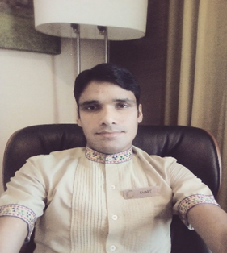

SUMIT JAKHMOLA
VPO.GATKOT, DISTT. PAURI GARHWAL.
UTTARAKHAND.
MOB. 9917606453, 8469534296
E-MAIL. Sumitjakhmola10@gmail.com

CAREER OBJECTIVE

To work sincerely and activity with an organization which provide me the challenging opportunity where I can use my potential to the best achievement of organization objective and to seek personal growth with development of organization.

EDUCATION QUALIFICATION

10th pass from U.K.Board at 2008
12th pass from U.K. Board at 2010

EXTRA ACTIVITY

1 - One year 6 month computer diploma Talley + Basic knowledge from S.C.I.T. Naziabad (U.P.)
2 – I have done one year Hotel Management course Monal Institute of Management Study Kotdwara
(Uttarakhand) with certificate.

WORK EXPERIENCE

1 – Six month industrial training from Lemon Tree Hotel Chandigarh.

2 - Six month job training from Calangute Tower Goa.

3 – 2 year experience in ITC Fortune Park Dahej Gujrat. (One year experience as a room attendant and
One year experience as a Sr. room attendant) and 2 year experience as a Tr . supervisor.

TECHNICAL EXPERIENCE:

- Basic Computer Knowledge
- IDS knowledge

HOUSEKEEPING
- Knowledge about Carpet and shampooing.
- Taking inventories for Linen, glassware and Chinaware used in guest rooms
- Handling Minibar consumption report daily and Lost and Found register
- Updating and following through the pending maintenance, coordinating with engineering for completion
- Scheduling for all types of cleaning of the hotel and on special cleaning
- Making guest room in the hotel standard

PERSONAL DETAILS

Name - Sumit jakhmola
S/O - MR.Dharmendra jakhmola
D.O.B.- 10/10/1992
Sex - Male
MARITAL - Married
Nationality - Indian

SUMIT JAKHMOLA

