CURRICULUM VITAE
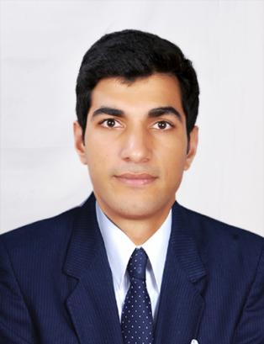
SHOWKAT GUL
Chichilora Magam
Tehsil: Karhawama
District: Baramullah,
Kashmir - 193401
CONTACT NUMBER: +91 6005531995
E-mail - aashiqgulzargar@gmail.com

Objective
To give my best in my Professional Pursuit for overall Benefit and Growth of the company that I serve by facing the challenges and use every moment of my tenure for learning..
Educational profile
Qualification  Level | Name of institute | University/board | Year of passing
Bachelor’s Degree in Hotel Management  (BHM-4 Years) | Lourdes Matha  IHMCT,  Trivandrum | University of Kerala | 2019
10+2 | Govt. Higher Secondary Institute, Kunzer | Jammu and Kashmir Board of School Education | 2014
10th | Govt. High School,Kunzer | Jammu and Kashmir Board of School | 2012

Experience

- One year and 4 month experience in THE OBEROI, GURGAON as housekeeping assistant.

- 6 months industrial exposure training in a five star hotel (THE RITZ-CARLTON BANGALORE)
- One month specialization training in a five star hotel ( THE LALIT GRAND PALACE SRINAGAR)

Personal achievement
- Attended class of Human Resources by Open2Study.
- Participated in “ALIMIPASSO” Food Festival 2016.
- Certificate of participation in the Kerala university/All Kerala inter-collegiate Cricket tournament.
- Started Dried Fruits business in November 2017.
- Received 7 “FIRST CLASS CARDS” from The Ritz-Carlton, Bangalore.
- Appreciation Letter from Malabar Café of Grand Hyatt Kochi Bolgatty.
Key Skills

- Self-motivated, initiative, high level of energy.
- Deals with Positive Attitude and Honesty.
- Resourceful and productive with good sense of humor.
Adaptable to all situations.
Personal Interest

Making Friends, Dancing, Playing Cricket, Travelling

Languages
- English (Proficient)
- Kashmiri (Fluent)
- Urdu (Fluent)
- Hindi (Fluent)
- Arabic (Conversational)
- Malayalam (Conversational)

Personal Details
Father's Name | Gh Mohd Zargar
Date Of Birth | 24-March-1998
Nationality | Indian
Gender / Marital status | Male / Single
Religion | Muslim

REFERENCE
Mr.Ranjith Pillai
Principal,
LMIHMCT, Kuttichal,
Trivandrum, Kerala
Phone- +91 472 285330, 2851348
Fax- 04722851348

Declaration
I, here by confirm that all the details provided above are true to the best of my knowledge.

Place

Date

SHOWKAT GUL

