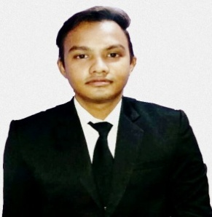
KUMAR SHANU
Contact No :- 6204192954
E-mail:- rajrohan4455@gmail.com.
QR.NO- L 640 SAHARPURA, SINDRI, DHANBAD,
PIN- 828122 STATE- JHARKHAND,P.O. - SINDRI
Career Objective
- To work stimulating environment where I can apply and enhance my knowledge and skills to serve the organizational objectives to the best of my efforts.

Professional Qualification
- Completed 3 years of B.Sc. Hospitality & Hotel Administration from Institute of Hotel Management Hajipur, Co- Administrated by NCHMCT Noida & IGNOU (Under Ministry of Tourism, Govt .of India).

Educational Qualification
• 10th from CBSE Board (2012)
• 12th from CBSE Board (2014)

Computer Proficiency
- Basic knowledge of Computer, internet skills and Microsoft Office.

Work Experience
• Successfully completed 17 weeks Industrial training from Hotel MARRIOTT HOTEL
WHITEFIELD, BANGALURU in all four major departments.
- Worked at JP PLACE HOTEL & CONVENTION CENTE, AGRA .
- Worked as floor attendant. To handle a floor of 28 rooms.
- Worked as desk attendant, know how to make report , Handle mail, Triton, Guest call, Room status Etc.
- Present Working at Crowne Plaza Ahmedabad.
Personal Details
Father’s Name : - Mr. Rameshwar Prasad
Date of Birth :- 30th Aug 1997
Languages known : - English, Hindi
Nationality : - Indian

Hobby
• Video Production

References
• Miss- Parimendar Mittal chowdary, Sr. Faculty, IHM Hajipur, Vaishali
Tel. No.+91-919576481420

MR.:- Santosh Sharma Housekeeping Supervisor Crowne Plaza Ahmedabad Mob:- 9630775536

Declaration
I do hereby declare that belief .the above furnished particular are true and correct to the best of my knowledge.

Date:- Signature-

