Resume

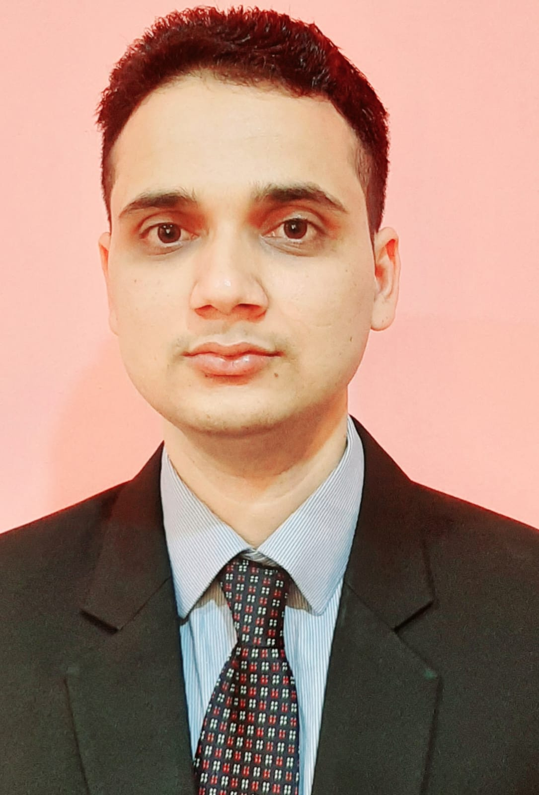
Naveen Kumar
Address: vill+post :yadochhapar,ps :Chanpatia,district:westchapran
,BIHAR 845450
Contact Details: +91 7857875506

Email:naveenkumarojha078@gmail.com
Skype ID: +919546220516
LinkedIn: naveenkumarojha078@gmail.com

Objective :

Seeking an opportunity, where exceptional customer service skills will be utilized to improve the customer base and maximize hotel’s profitability.

Executive Summary :

- Result oriented Housekeeping Professional with 5 years experience in Housekeeping.
- Excellent interpersonal, communication and organizational skills.
- Excellent leadership skills.
- Person having clear vision of my own future objectives and self-discipline to achieve organizational goals.
- Excellent attention to detail and high multi-tasking capability.
- Self-motivated and flexible to work with negligible supervision.
- Able to meet deadlines along with working under pressure.

Work Experience :
•currently working Radisson blu udaipur palace resort and spa as a housekeeping supervisor form 29 January to till present.
•Worked at gold finch hotel faridabad as a housekeeping supervisor form 6 February 2020 to 19 January 2021.
•Worked as a accociate / Desk Attendant Pre- open Park Regis Lotus Hotel, Bahrain 26October 2017 to 26 October 2019
•Worked as accociate at Grand Hyatt, Goa from May 2017 to September 2017.
•Worked as accociate The Zuri White Sands Resort and Casino, Goa from June 2016 until April 2017.
•Successfully completed trainee from Hotel Chancery Pavilion Bengaluru, India from May 2014 - October 2014.

DUTIES & RESPONSIBILITIES

- Handling housekeeping desk and minibar items inventory.
- Ensures a positive overall impression of the hotel property as well as providing necessary service of ensuring clean and comfortable rooms for guests.
- Respond promptly to requests from guests and other departments
- Responsible for cleaning of assigned floor, room, corridor and pantry.
- Make sure all extra cleaning done on given time weekly and monthly.
- Send occupancy report on time.
- Vacuum carpets and perform guest rooms and hallway floor care duties.
- Inform and deposit lost and found articles immediately upon finding them.
- Register and do follow up if any maintenance found in the room while servicing.
- Follow DND procedure and inform accordingly.
- Knowledge of IDS, Word and Excel.

Educational Qualification :

- Studied Hotel Management from IHM Hajipur patna. (2013-2016)

- Passed H.S.C from BSEB Board patna bihar(2011-2013)
- Passed S.S.C from BSEB Board patna bihar. (2010-2011)

Computer Skill :

- Operating Systems
- Office Management Tools
- Windows XP, Window 7
- MS Word, MS Excel Power Point
- Micros
- Opera
- Winhms.

PERSONAL DETAILS
 | Gender | MALE
 | Nationality | INDIAN
 | Date of Birth | 31-03-1996
 | Marital Status | Unmarried
 | Father’s Name | Mr. Narendra Kumar
 | Visa status | Employee visa {Bahrain}
 | Language Proficiency | English, Hindi, and Bhojpuri.
 | Passport no. | PO713103

HOBBIES
- Playing and watching cricket
- Listening to music
- Watching movies
REFERENCE
Mr.Jagdish Sharma
Executive Housekeeper
Park Regis Lotus Hotel, Bahrain
Mail: jagdishsharma1605@gmail.com

Mr Anupam
Sr lecture
IHM Hajipur
Mobile number:+919031286077

I hereby certify that all information provided is accurate and updated to the best of my knowledge.

(Naveen kumar)

