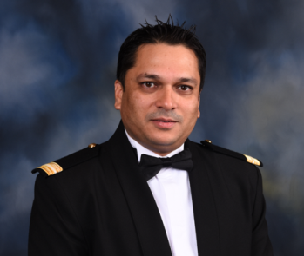
Harshad Padte
Room No2-Gomes Wadi,DS Babrekar Marg
Gokhle Road Dadar West-400028
Cellular: 00917507646187/9370915628
E-mail: HarshadPadte24@gmail.com

OBJECTIVE
To join as Housekeeping Manager and contribute guest experience whilst also growing and developing myself.

WORK EXPERIENCE
- Worked as Housekeeper in Orchid Hotel (Ecotel) in Mumbai airport from 1997 to 2002.
- Worked as Room attendant and Floor supervisor in P&O Cruises from 2002 to 2010.
- Worked as Assistant Housekeeping manager in Lalit intercontinental hotel in Mumbai airport from 2010 to 2012.
- Back to P&O Cruises as Assistant Housekeeping Manager from 2013 to 2019.
- Working with Apollo Cruises as Assistant Chief Housekeeper from 2019 until now.

Apollo cruises & P&O Cruises (Carnival UK/ Carnival Corp)
Assistant Manager, Housekeeping
Responsibilities
- Audit staff Hours of Work/Rest records
- Complete performance reviews and appraisals
- Manage performance improvement within the team
- Investigate, manage and complete minutes for disciplinary and grievances’
- Inspect & monitor areas of responsibility; including pantries, lockers, launderettes, general areas &
- cabins
- Monitor stock levels and requisition new stock from stores as required; including consumables,
- chemicals, cabin amenities, equipment and linen
- Follow up on Guest feedback and take necessary action as required
- Report and respond to Guest feedback
- Implement, manage and document the execution of cleaning schedules and duty programmes
- Produce rotas, and ensure staff are deployed on watches accordingly
- Manage the berthing and deployment of the Housekeeping team
- Implement, manage and execute Public Health Policy & Procedure within areas of responsibility
- Manage the collection and delivery of baggage to cabins
- Audit Suites – all Suites to be checked at least once per calendar month
- Assist with the management of the Laundry Operation
- Supervise the activity of the Butlers and Housekeepers (Deck) and provide advice where needed
- Deputize for the Housekeeping Manager when necessary

Achievements
- Regularly achieve and exceed guest satisfaction score targets. For example, have exceeded targets for all but one voyage during my current tour of duty.
- Have a record of success and earning recognition for my team. For example, during this tour of duty I have been awarded the ‘Team of the Month’ award two consecutive months for my Laundry Department.

- I have a track record of doing whatever it takes to achieve my targets. During my current tour of duty for example, I have achieved my revenue targets for 100% of my cruises.

EDUCATION
- Hotel Deploma-- Completed from Maharashtra Board.
- Higher Secondary School examination from Chambur English College of Commerce, and Arts
- Secondary School examination from Chambur English
- First Aid Certified- Carnival UK
- Certified, Integrated Pest Management Level 3- Nutristat/ Carnival UK
- Food Hygiene Course from UK
- Quality Customer Service training for the Tourism Industry from UK
- Handling Man Power Training from in UK
- Management of Health and Safety in UK
- STC W 95 Form UK
- Chemical Handling.

REFERENCES
Available upon Request

