CURRICULUM VITAE
ARTEE PAUNIKAR  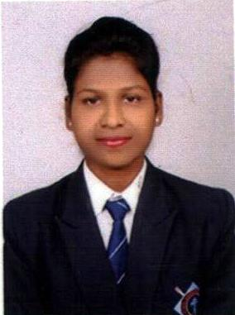  Permanent Address  Artee Paunikar  Near New VCA Stadium ,  Jamtha , Dist. Nagpur.  Contact Details:  Cell no: 9325916074  E-mail :- arteepaunikar@gmail.com  Personal Data  Father’s name : Mr. Chhotu Paunikar  Mother’s name : Ms. Chanda Paunikar  Date of Birth :18/05/1997  Sex : Female  Height : 5.3  Weight : 52 Kg  Nationality : Indian  Marital Status : Unmarried  Hobby :Reading Books ,  Listening Song,  Singing Song  Languages : English,Hindi,Marathi  Key skill  - Strong Work Ethic  - Punctuality.  - Ability to Accept & Learn From Criticism | Objective  To be a part of an estemeed organization which will offer me a challenging platform in my career as well as assist me in enhancing my abilities to go ahead.  Education  Professional qualification:  - I have done graduation (BHMCT) from Tuli college of HMCT Nagpur.  Academic qualification:  - Passed 10th from Janata High School, Nagpur Board 2013-14.  - Passed 12th from Jijamata Jr. College, Nagpur Board 2015-16.  Industrial Training:  - Taken part in events as ODCs in many Hotels  - 3 month at ITC Fortune Hotel Lavasa , Pune  - 3 month at Pride Plaza Hotel, Ahemedabad, Gujrat.  Computer Porficiency:  - Ms-CIT  Extra curricular activities:  - Participated in various Event at school.and collage  - competitions at college and school levels.  - Participated in English communication skill programme.  - Participated in various Theme Dinners at college levels.  Department of Interest:  - Housekeeping  I have 1 1/2 year experience from Radisson Blu hotel Nagpur in Housekeeping department.

Date:- 19/10/2020
Place: - Nagpur (Artee Paunikar)

