resume

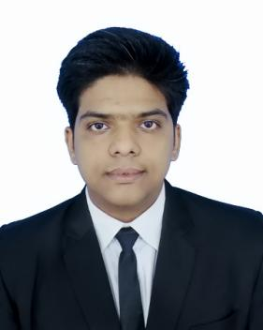  PERSONAL profile:  Name:  Ahtasham Alam  Fathers Name:  Md. Fakhre Alam  Date of birth:  03rd February, 2000  Nationality:  Indian  Permanent Address:  Ward No. 8, Agarpur, Lalganj, Vaishali, Bihar(844121)  Contact:  (+91) 9110972605  E-mail:  1841210008ahtasham@gmail.com  Linked In:  https://www.limkedin.com/in/1841210008ahtasham  Language Proficiency:  - English, Hindi, Urdu | Objective:  Seeking for an opportunity to begin my career in a high-level professional environment where I can utilize my training, Hotel management studies background and skills to the maximum while making a significant contribution to the success of company.  Education Qualification:  Industrial Exposure Training :  Organization- HYATT REGENCY AMRITSAR  Training period – 17 Weeks (July 2019 to Oct 2019)  Location – Amritsar  Area of interest :  - Accommodation Operation  Soft Skills:  - Team Work as well as Work on my Own.  - Self-motivated.  - Quick learner.  - Ability to complete the assignment in the given time frame.  Co-Curricular Activities:-  - Participated in Covid-19 Awareness Quiz on COMBATING COVID-19.  - Attended webinar by SRM-IHM on New Normal in the Hospitality during COVID-19.  - Coordinated as a team member of Accommodation Operation Department in the Institute.  - Admin of Housekeeping Club of Institute.  - Participated in a poster making event on International Tourism Day held on 2020.  - Participated in Short video making event on International Tourism Day held on 2020.  Strength :  - Have faith in synergy and co-operate with other.  - Hardworking and Self Confident.  - Easily Adaptable To Working Environment.  - Always Keen To Take Initiative.  Hobbies :  - Getting Knowledge about upcoming Smartphones Trends.  - Going out for Walk and Experiencing the Nature.
  Examination | Board | Status | Year
  B.Sc. in Hospitality & Hotel Administration | NCHMCT  &  IGNOU | Pursuing | 2018-2021
  12th | BSEB | Pass | 2017
  10th | CBSE | Pass | 2015

Declaration:

I hereby declare that the information mentioned above by me is true to the best of my knowledge and belief.

PLACE: IHM HAMIRPUR
DATE: (AHTASHAM ALAM)

