Resume

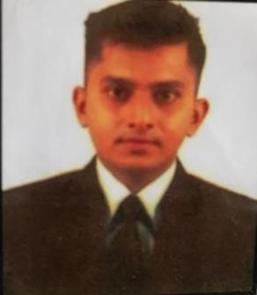
Mr. Aakif Rafik Mujawar
DOB: 27th April 1993
Address: H. No. 489 Durgavad Sarmbal,
Kudal, Sindhudurg,
Maharashtra - 416520
Contact No: 8888777210 / 9422307893
Email Id: aakifmujawar786@gamil.com

Career Objective
To make my career in hotel management field by using my good management skills for the mutual growth.

Educational Qualification
-1 Year Diploma in Hotel Management & Catering from Ann Institute of Hotel Management & Catering Technology Goa in year 2016 with 55.5 %.
-Passed Bachelor of commerce graduate from Yashwantrao Chavan Maharashtra Open
University in year 2015
-Passed High school from Kolhapur Board in year 2008 with 69.07%.

Other Qualification
-2 year Diploma in Stenography & Secretarial Practice from Maharashtra State Board of Technical Education in year 2012 with first class.
-MS-CIT from MKCL in year 2010 with 80%.
-IT from Maharashtra Business Training Board in year 2010 with 70.05%.

Work Experience
- 5 years in a hotel industry.
-Working in housekeeping department as Team leader in “RADISSON GOA CANDOLIM” Working since February 2019 to till the date. Also handling the responsibilities of an executive at the same time.
- worked as Sr. housekeeping associate in Radisson Goa Candolim.
-Worked in housekeeping department as Guest Service Associate in 5* hotel “THE PARK BAGA RIVER GOA”. This is pre- opening property. Working since November2017 to December2018.

-Successfully done Industrial Training & Job Training programme.

Duties and Responsibilities for Team leader
- To assign guest rooms and common areas to housekeeping staff.
- Inspect rooms for cleanliness and job orders.
- Checking common areas for cleanliness.
- Help in Hiring and training the housekeeping staff.
- Order cleaning supplies and equipment’s.
- Create employee schedules.
- Taking different inventories.
- Give regular report to senior/ manager.

Key Skills -Good listening skills.
-Team management.
-Good leadership skills.
-Good motivator.
-Hard working.
-Disciplined.

Hobbies
- Plays cricket and Volley ball
- Dancing
- Driving

Reference
- On request

