CURRICULUM VITAE

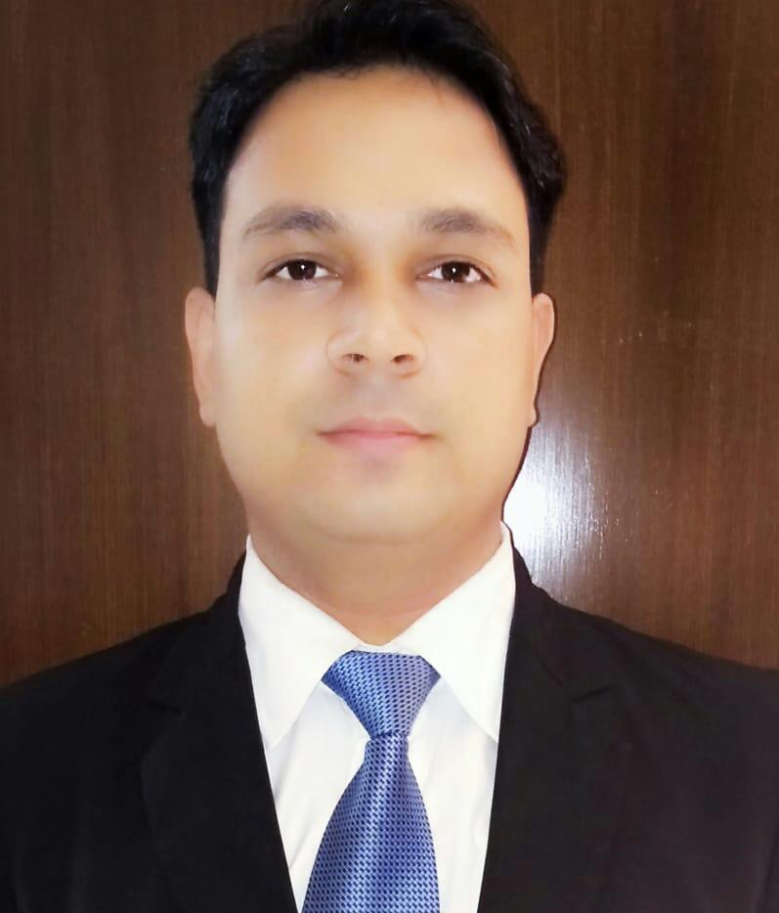
Sandeep Upadhyay
Looking for managerial assignments with a Reputed Organization

AREAS OF EXPERTISE
Operations:
- Developing and implementing procedures, working on cost controlling ensuring revenue optimization for the organization and maintaining the highest standards of hygiene and quality standards.
- Streamlining processes and coaching the staff regularly to adhere to the set guideline.

Food and Beverage Management:
- Impart appropriate training on Food Presentation, Service Excellence and Teamwork, Cost control, Customer delight to the restaurant and support service staff.

Client Relationship Management:
- Ensuring high-quality services, resulting in customer delight and optimum resource utilization for maximum service quality.
- Ensuring maximum customer satisfaction by closely interacting with potential clients & understand their requirements and customizing the product and services accordingly.

Vendor Management:
- Managing Operation related Vendor and ensuring the highest standards are to be achieved in all the services and procurement.

People Management/Training:
- Imparting appropriate training on Service Excellence and Teamwork to restaurant and support service staff.
- Assigned Trainer of the department to train the Staff at the Associate and Executive level from all Outlets.
- Departmental trainees are getting trained with their basic academic qualification and as per Outlet requirement.
- Training to the staff over operating machines and POS.
- Training of Outlet Food and Bar Menu.
- Training over Handling the CGHS and Liquor inventory.
- Training over Monthly Training Calendar.

WORK EXPERIENCE
1st September 2021 onwards working with Jingalala Resort at Gurugram as Resort Manager.

January 2020 onwards Working with International skills academy as faculty of F&B Service and F&B Management.

3rd June 2019 - 24th November 2020 - Restaurant Manager at The Umrao NH 8, Samalkha, New Delhi.

1st October 2016 – 4th April 2019 - Assistant Manager at Lemon Tree Premier, Aero city New Delhi.

1st March 2013 – 30th September 2016 – Guest Service Executive at Lemon Tree Premier, Aero city New Delhi.

15th October 2012 – 28th February 2013 - Guest Service Associate at Lemon Tree Vembanad Lake Resort, Alleppey.

1st September 2010 – 14th October 2012 - Guest Service Associate at Lemon Tree Hotel, Ulsoor Lake, Bangalore.

1st July 2009 – 31st August 2010 – Guest Service Associate at Golden Palm Hotel & Spa, Bangalore.

16th August 2008 -- 15th January 2009 – Industrial Training at Sovereign the heritage Hotel Bangalore.

Duties & Responsibilities:-
- Revenue Budgeting
- Guest feedback Management
- Restaurant Management
- DashBoard management.
- Responsible for making reservations and coordinating with guests for resolving their concerns/ needs. Co-ordinate with operating staff
- Preparation & monitoring of Food & Beverage budgets and responsible for sales, costs and inventory control.
- Handling operational functions like pre-shifts staff briefings, creating the duty roster, shift management.
- Organizing and conducting practical and theoretical training programs, to enhance skills and motivational levels.
- Taking booking for the events & making menu on different occasion
- Area Planning and Modification as per Guest requirement.
- Decide price of packages
- Arranging the theme events
- Taking care of guest complaints and handle the situation diplomatically.
- Supervising the operations.
- Ensuring maximum client satisfaction and understanding their requirement.
- Taking pre-shift briefing and making the duty roster
- Imparting appropriate training on service excellence and teamwork to restaurant and support service Staff
- Taking care of Bar inventory
- Working as Diplomatic Manager
- Day End Operation Reports
- Month End Operation Reports
- Outlet Promotion on Online Channels.
- Revenue Generation Idea Implementation.
- Day to day observation on Restaurant Ranking.

TRAINING PROGRAMS
- I have done Industrial Training for six months as Industrial Training during the tenure of my Hotel Management Course from Sovereign The Heritage Hotel.

ACADEMIC CREDENTIALS
- Done Bachelor of BBA-HM from Sam Hissing bottom Institute of Allahabad University in the year 2011.
- Done 01 years diploma in Hotel Management from Bhabha Institute of Management Science year 2008.
- Did schooling from Allahabad Board (U.P.) in the year 2007.
- Did Indian Sign Language short course at Lemon tree Premier Hotel.
- Did certificate course of French Language from Alliance Frances.
- Did Certificate course of Basic Computer from IIHT Bangalore.
- Did Fire fighting training Course at LTP Ulsoor Lake Bangalore.
- SSDP (Supervisor Skill Development Program)
- TTT (Trained The Trainer) Program.

STRENGTH
- An expressive mind with the ability to think clearly and logically.
- Ability to work accurately and pays attention to details.
- Excellent spoken and written communication skills, problem-solving, and leadership skills.

PERSONAL DETAILS

ADDRESS: - Kailash Nagar New Bypass Road near J.K. Convent School Street no. 4 Firozabad 283203

Mobile- 9717681464
E-Mail I.D-: sandeepupadhyay221@yahoo.com
D.O.B- 09th June 1990

