SUBAL KUMAR MANDAL  Contact Information:  PERMANENT ADDRESS:  AT: NARENDRAPUR  PO- BAINCHA  BLOCK-CHANDABALI  DIST :BHADRAK  Pin :756164 ( Odisha)  E-Mail  kumarsubal217@gmail.com  Contact No.  Mobile:- +91 9776774174  +91 8218014732  Personal Data:  Date of Birth :24/04/1997  Father's Name :  Mr.Chitta Ranjan Mandal  Sex : Male  Height : 5ft 7 inch  Weight : 55 kg  Eye Sight : Normal  Nationality : Indian  Marital Status : Single  Passport Details  Number-S1820686  Issue Date-23 October 2018  Date Exp- 22 .Oct. 2028  Place of Issue- Bhubaneswar |  | RESUME  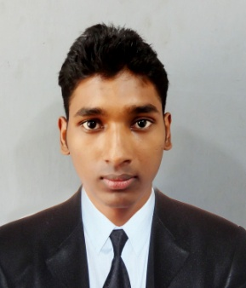  OBJECTIVE  - To make my career in hotel management field by using my good management skills for the mutual growth.  Area of Specialization– FOOD & BEVERAGE SERVICE  PROFESSIONAL QUALIFICATION  - Completed Bachelor in Hotel Management under Utkal University of Culture, Bhubaneswar, Odisha.  - Completed diploma in professional barteding course from UTTARKHAND BAR ACADEMY HLD.  WORK EXPERIENCE  - I worked as a Bartender in STARLIT LAUNGE BAR BHUWNESHWAR.  - Completed Industrial Training from Hotel The Gate Way ,Agra , Taj Group( 5* Hotel).  - Completed Job Training in Food and Beverage Service from Courtyard by Marriott Hotel, Ahemadabad ( 5* Hotel).  - 2 years of experience as GSA in FOOD & BEVERAGE SERVICE from Millennia Regency, Lucknow.  - Participated in inter house flair challenge in UBA academy.  SPECIAL ACHIEVEMENT : -  - Received Best Job Trainee Award from Courtyard by Marriott Hotel, Ahmedabad, India (5* Hotel).  ACADEMIC QUALIFICATION  - Successfully Completed High School Certificate Examination Under BSE, Odisha in 2013.  - Successfully Completed Council of Higher Secondary education Examination, Odisha in 2015.  COMPETENCIES  - Work effectively with diverse groups of people.  - Ambitious and committed to excellence.  - Sincere with a high level of integrity.  LANGUAGES KNOWN  - English : Read, Write and Speak  - Hindi : Read, Write and Speak  - Oriya : Read, Write and Speak  HOBBIES & INTERESTS  - Listing Music.  - Cooking  STRENGTH :-  - Disciplined, dedicated and hardworking with an ability to easily adapt to change work environs and cultures.  - Keen learner with ability to learn and imbibe new knowledge with ease.  - Good team worker and facilitator with strong people managed skills.  DECLARATION :-  I do hereby declare that all the above information given is true to the best of my knowledge.  Place:  Date: (Subal Kumar Mandal)

