MUKESH SINGH MAHAR

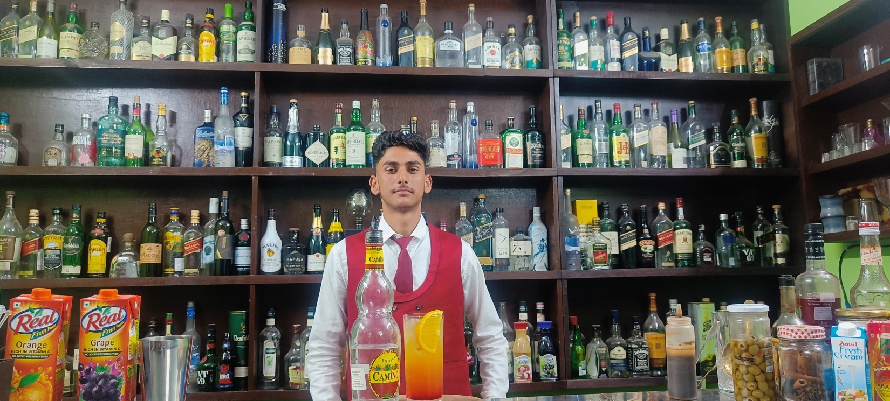

Address CHAMPAWAT
State Uttarakhand
Contact No 9456374324
Email : mukeshmahar07@gmail.com

Career Objective

- I focus my career to learn and enhance my skills in handling every opportunity with focus, determination and teamwork. Always open to accept new challenges.

Educational/ Qualification:-

- Diploma in professional bartending course from uttarakhand bar academy haldwani.
- Persuing graduation in B.A from kumaun university haldwani.
- Passed Senior Secondary from CBSE Board, in the Year 2019.
- Passed Secondary from CBSE Board, in the Year 2017.

EXPERIENCE

- I worked as a BARTENDER in ITC FORTUNE launge bar haldwani.
- Participated in inter house flair competition in institute .
- Got appreciation letter for active participation in festive season decoration set up 2022.
- Got numerous certificates in school events.

KEY RESPONSIBILITY

- Making cocktails & mocktails according to company standard .
- Making good interaction with guest and taking care of guest satisfaction.
- Closing bar , maintain checklist and deposting cash.

Hobbies/ Interests

- In my free time I like to do physical activity like playing, running & flairing.
- To relax I prefer to listen song especially on my bed. it Helps me concentrate in a better way.

STRENGTH

- Honesty
- Team work skills
- punctual
- Quick learner

Personal Details

- Father’s Name : MR. NATH SINGH
- Date of Birth : 16 JUNE 2001
- Language Known : Hindi, English
- Height : 170 CM
- Weight : 65 KG

Signature:……………………
Date: - …………..
Place: - ………….

