References:
Kasam nuthan Kumar (General Manager)
9000190855
kasamnuthan@gmail.com

Madduri Vijay Bharath
9676444497
mvbharath23@gmail.com

Experience:

Worked as a Assistant Executive housekeeper in Accor Qatar August 2022 to till the date

Worked as a Executive housekeeper in Alexander luxury hotel Jan 2021 to jul 2022

Worked as a Deputy housekeeper in Mrugavani resorts & spa 2020 Jan to 2021 march.

Worked as Housekeeping Assistant manager in Safi landmark hotel & suites Afghanistan September 2018 to 2019Dec.

Worked as HouseKeeping Executive in Hotel Best western Ashoka Hyderabad 2018 April to sep 2018.

Worked as Housekeeping Executive in Quality Inn Residency Nampalli 2016 Nov to 2018 Feb.

Worked as Senior HK Supervisor in The Kay Hotel Vijayawada 2016 May to 2016 November.

Worked as senior HK Supervisor in Hotel Park N Vijayawada 2014 May to 2016April.

Worked as HK Supervisor in Hotel Anandhi Bhimavaram 2013 Jun to 2014 April.

Worked as HK Supervisor in Hotel Ishwarya Grand Kakinada from 2011 May to 2013 May.

Training faculty in OMCAP organization through western collage of hotel management Vijayawada 8 months.

ACHIEVEMENTS:

Won Debate Competition in Mandal level

Actively Participated in various sports activities for inter school
- Participated Paper presentation

CO-EXTRA-CURRICULAR ACTIVITIE:

Member of Debate Competition in ZPBH School.

IT PROFICIENCY
- Microsoft Office Word, Microsoft Office Excel, Microsoft Office Power Point
- Internet Browsing.
- IDS

Skills
- Teamwork .
- Problem solving and self-motivated.
- Cost control and Inventory .
- Creative ideas help full department.
- Multitasking
- Adoptability
- Time Management
- Handling Pressure

Education

- Certified Hospitality Executive
Acharya Nagarjuna University(2010)
- Diploma
State board of Technical and Training(2009)
- SSC
State board of Education (2006)

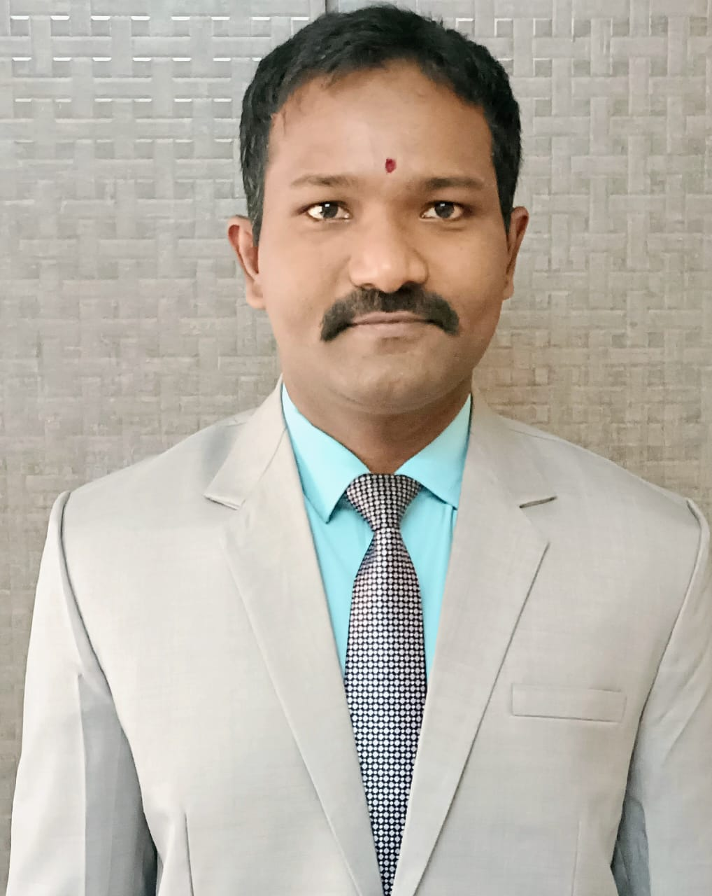

L. Kiran Kumar

Contact

S/O Sambasiva Rao

D.NO:3-2, Post office Street,

Purushotha patnam,

Gannavaram (MD),

Krishna (DT),

Andhra Pradesh,
Pin code: 521101.

l.kirankumar503@gmail.com

Contact No: + 91 96405 86682

+ 91 9182691148

l.kirankumar503@gmail.com

Contact No: + 91 96405 86682

+ 91 9182691148

