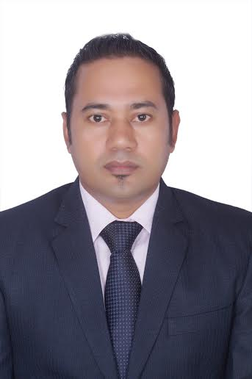

Surendra Singh Rawat

Contact No: +918879174337

Email Address: s.rawat8078@gmail.com

PROFESSIONAL SYNOPSIS
- Over 22 years of extensive experience in the hospitality industry encompassing Guest Relationship Management, Food & Beverage operations, Room division, Facilities Management and Training & Development.
- planning & implementing effective control measures to reduce running costs of the unit.
- Adept designing & implementing training programs for bringing keen customer focus, high energy level and team spirit in the employees.
- Proficient at overseeing Food & Beverage, catering operations and responsible for managing the catering for all kinds of social events, seminars & conferences as well as outdoor catering

EMPLOYMENT HISTORY
- Working In 4* The Emerald Resort in Old Mumbai Highway Dist. Pune with 35 Room
With 4 F&B Outlets & Banquets, Lawn from 01/01/2020 to till As a General Manager

- Worked In Royal Plaza 4* Hotel & Banquets from 01/11/2018 to 31/07/20 As a F&B Manager with 42 rooms, 5 banquets hall, 1 bar, room service , Restaurant

- Worked In 4* The Emerald Resort in Old Mumbai Highway Dist. Pune with 35 Room with 4 F&B Outlets & Banquets, Lawn from 01/01/2018 to To 31/10/2018 As a General Manager

- Worked In 4* Resort in Bin Masjid Hotels & Resorts in Ras AL Khaimah UAE with 253 Rooms with 6 F&B Outlets & Banquets As a F&B Manager from 28/11/2016 to To 30/11/2017

- Worked In Western Hotel (4*) In Abu Dhabi U A E 248 Rooms with 05 F&B Outlets & Banquets As a Asst F&B Manager 05/01/2016 to 25/11/2016

- Worked In Ecotel Hotels in The Lagoona (4*) Resort in Lonavala Pune India 120 Rooms with 05 F&B Outlets& & Banquets 16/04/2012 TO 01/01/2016 As a F&B Manager

- PRE-OPENING Team in UAE (5*) AL Hamra Hotels & Resorts at Acacia Hotel 373 Rooms with 07 F&B Outlets & Banquets AS A Restaurant & Bar Manager from 01/01/10 to 6/03/2012

- PRE-Opening Team ASRANI HOTEL & RESORT 4* star at The Beatle Hotel Mumbai AS Bar Supervisor from 22/ 07/ 2008 to 01-01-2010

- Worked as Bartender & waiter “HOTEL THE LEELA” Mumbai (A 5 star Deluxe) the essence of India from 011/08/1997-to 21-07-2008

Responsibilities
  - Holding regular briefings and meetings with all head of departments.
  - Looking Oversee the operations functions of the hotel, as per the Organizational chart.
  - Handing full compliance to Hotel operating controls, SOP’s, policies, procedures and service standards.
  - Leading all key property issues including capital projects, customer service and refurbishment.
  - Handling complaints, and oversee the service recovery procedures.
  - Responsible for the preparation, presentation and subsequent achievement of the hotel's annual Operating Budget, Marketing & Sales Plan and Capital Budget.
  - Managing on-going profitability of the hotel, ensuring revenue and guest satisfaction targets are met and exceeded.
  - Delivering hotel budget goals and set other short and long term strategic goals for the property.
  - Developing improvement actions, carry out costs savings.
  - Closely monitor the hotels business reports on a daily basis and take decisions accordingly.
  - Monthly financial outlooks for Rooms, Food & Beverage, Admin & General, on target
  - Preparing a monthly financial reporting for the owners and stake holders.
  - Drawing up plans and budget (revenues, costs, etc.) for the owners.
  - Helping in the procurement of operating supplies and equipment, and contracting with third-party vendors for essential equipment’s and services.
  - Doing final decision maker in hiring a key staffs.
  - Doing Coordination with HOD's for the execution of all activities and functions.
  - Managing and develop the Hotel Executive team to ensure career progression and development.
  - Responsible of department heads and take ownership of all guest complaints.
  - Responsible effective leadership to hotel team members.
  - Leading in all aspects of business planning.
  - Responsible to audits to ensure continual improvement is achieved.
  - Handling corporate client handling and take part in new client acquisition along with the sales team whenever required.
  - Responsible for safeguarding the quality of operations both (internal & external audits
  - Responsible for legalization, Occupational Health & Safety Act, fire regulations and other legal requirements.

ACADEMIC CREDENTIALS
- S.S.C Passed
- H.S.C Passed
- Degree in Hotel Management from Nehru Academy Institute Dehra Dun Uttarakhand
- Handling Micros, IDS, Showman, Material Management System.
- 1 Year Diploma in Business Administration Specialization in hotel from
- Handling Micros, IDS, Showman, Material Management System.

PERSONAL DETAILS
Marital Status: Married.
Languages Known: English, Hindi, Marathi (understand)
Hobbies: Driving, Reading and Traveling.
Address: New Mukund Park C wing 01 Bhayandar East Thane- East Pin- 401105

